1. Guess the output:

* var numbers = [1, 2, 3];  
  numbers.push(4);  
  console.log(numbers);
  + 1. [1, 2, 3, 4] guess [correct]
    2. [4, 1, 2, 3]
    3. [1, 2, 3]
    4. Error

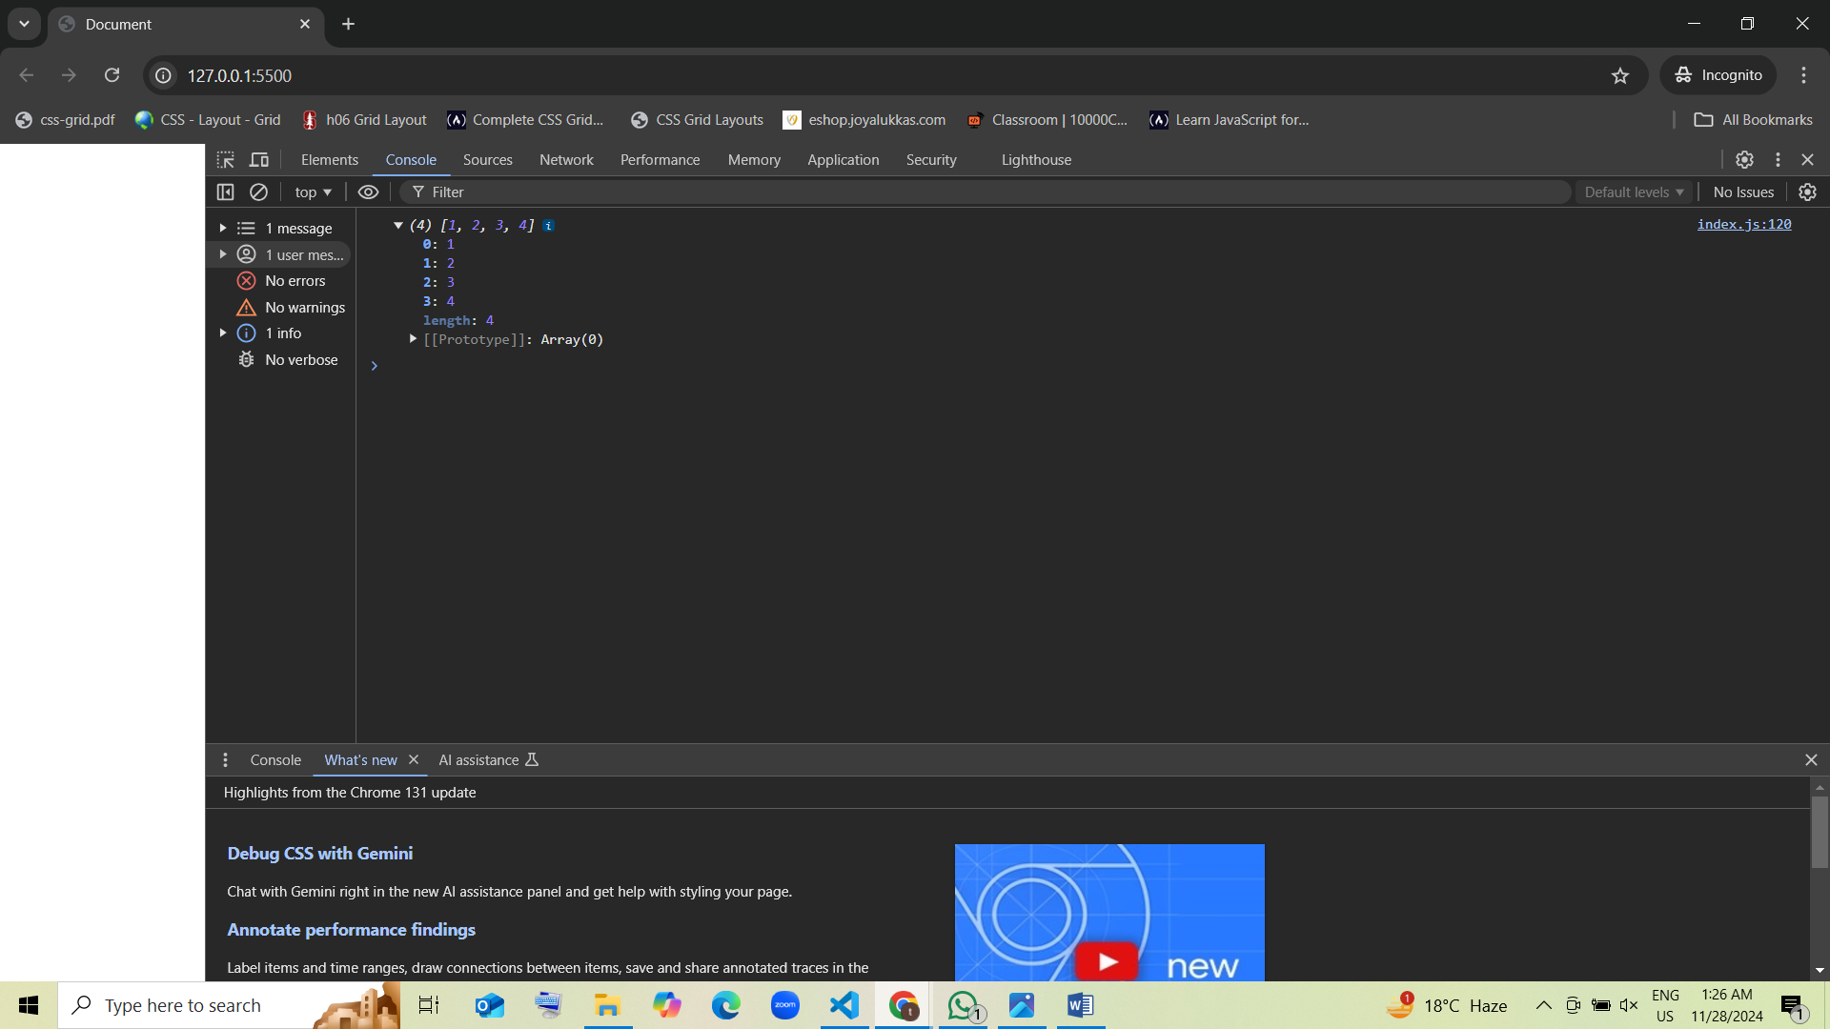

1. Guess the output:

* var fruits = ["apple", "banana", "cherry"];  
  var removed = fruits.pop();  
  console.log(fruits, removed);
  + 1. ["apple", "banana"], "cherry" [correct]
    2. ["apple", "banana", "cherry"], undefined guess
    3. ["cherry"], "banana"
    4. Error

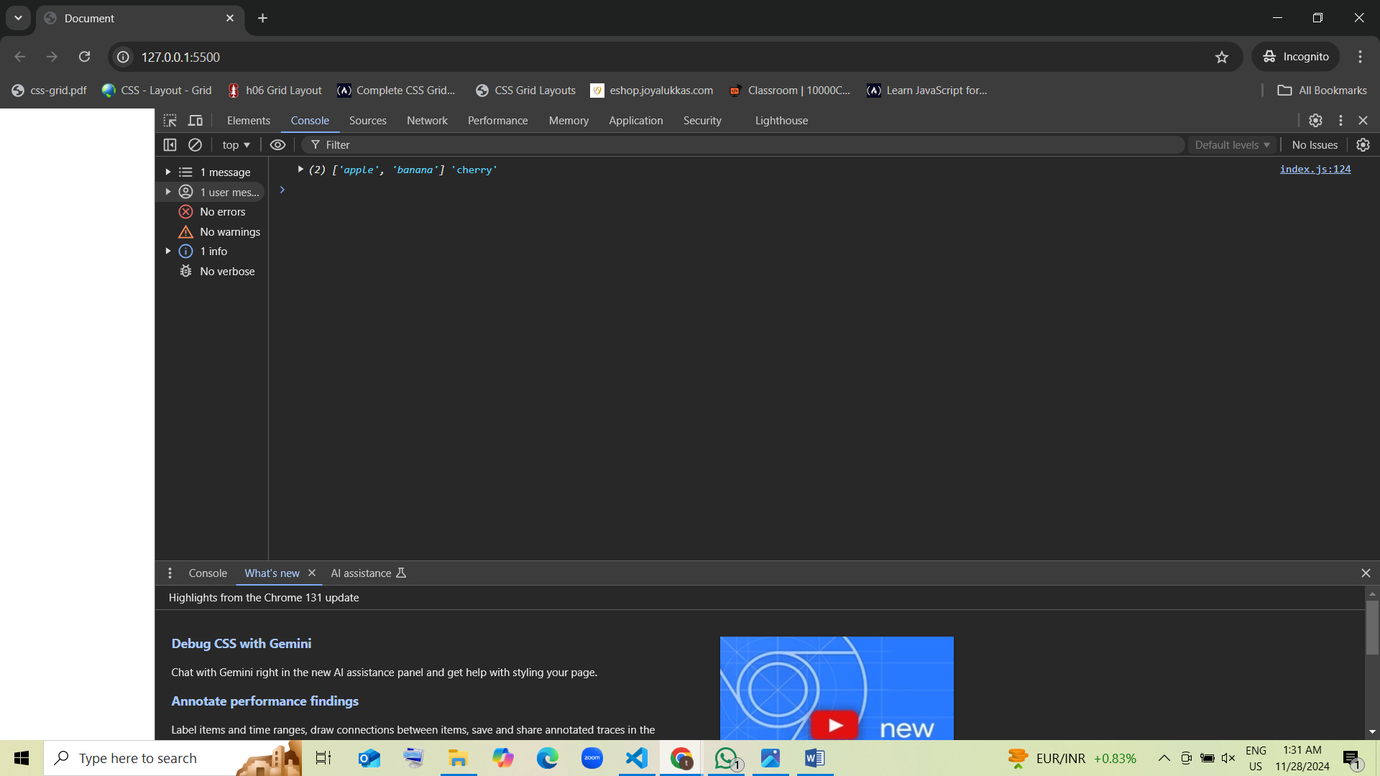

1. Guess the output:

* var numbers = [5, 10, 15];  
  var removed = numbers.shift();  
  console.log(numbers, removed);
  + 1. [10, 15], 5 guess [correct]
    2. [5, 10], 15
    3. [5, 10, 15], undefined
    4. Error

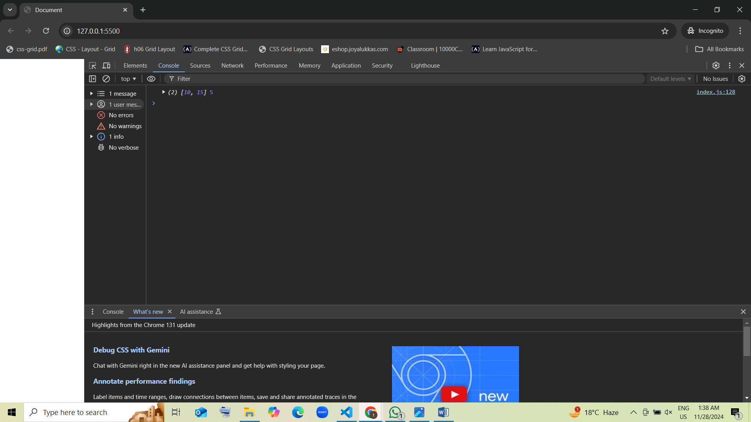

1. Guess the output:

* var animals = ["cat", "dog"];  
  var length = animals.unshift("lion");  
  console.log(animals, length);
  + 1. ["lion", "cat", "dog"], 3 guess [correct]
    2. ["cat", "dog", "lion"], 2
    3. ["cat", "dog"], 2
    4. Error

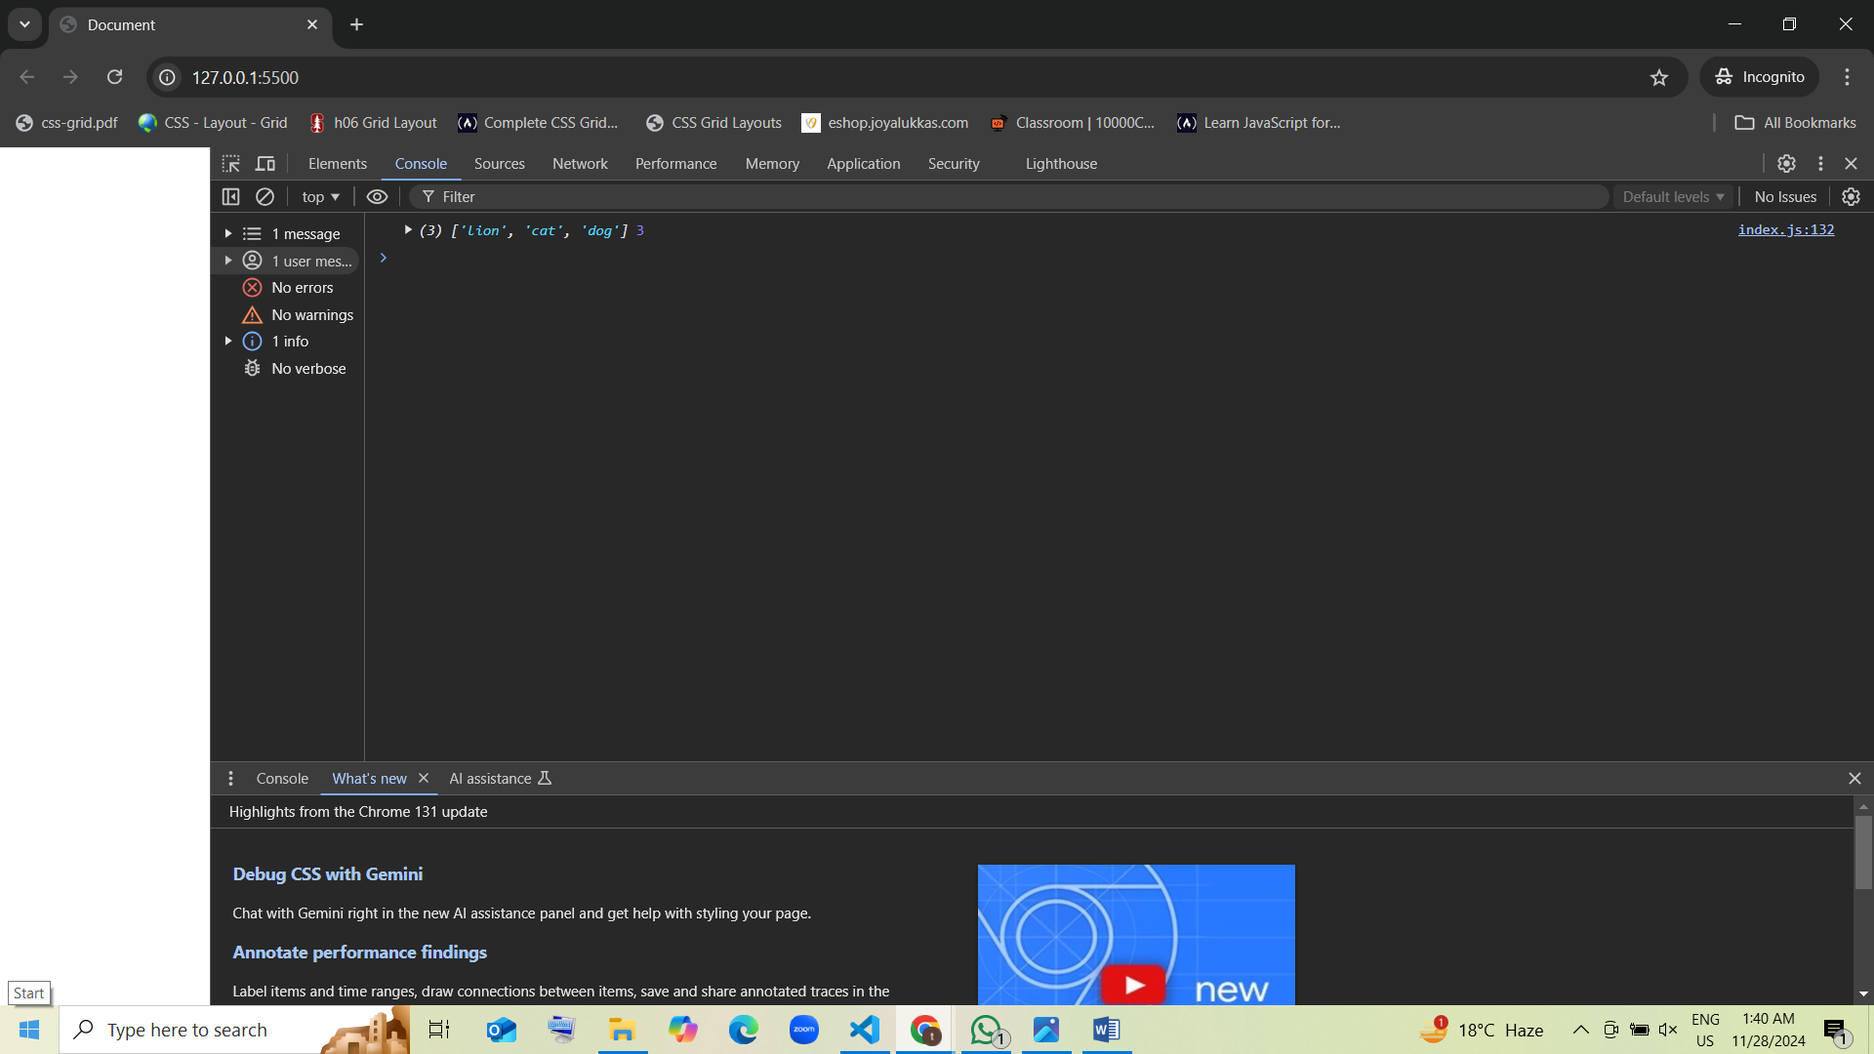

1. Guess the output:

* var data = [100, 200, 300, 400];  
  data.length = 2;  
  console.log(data);
  + 1. [100, 200] guess [correct]
    2. [100, 200, 300, 400]
    3. [100, 200, undefined]
    4. Error

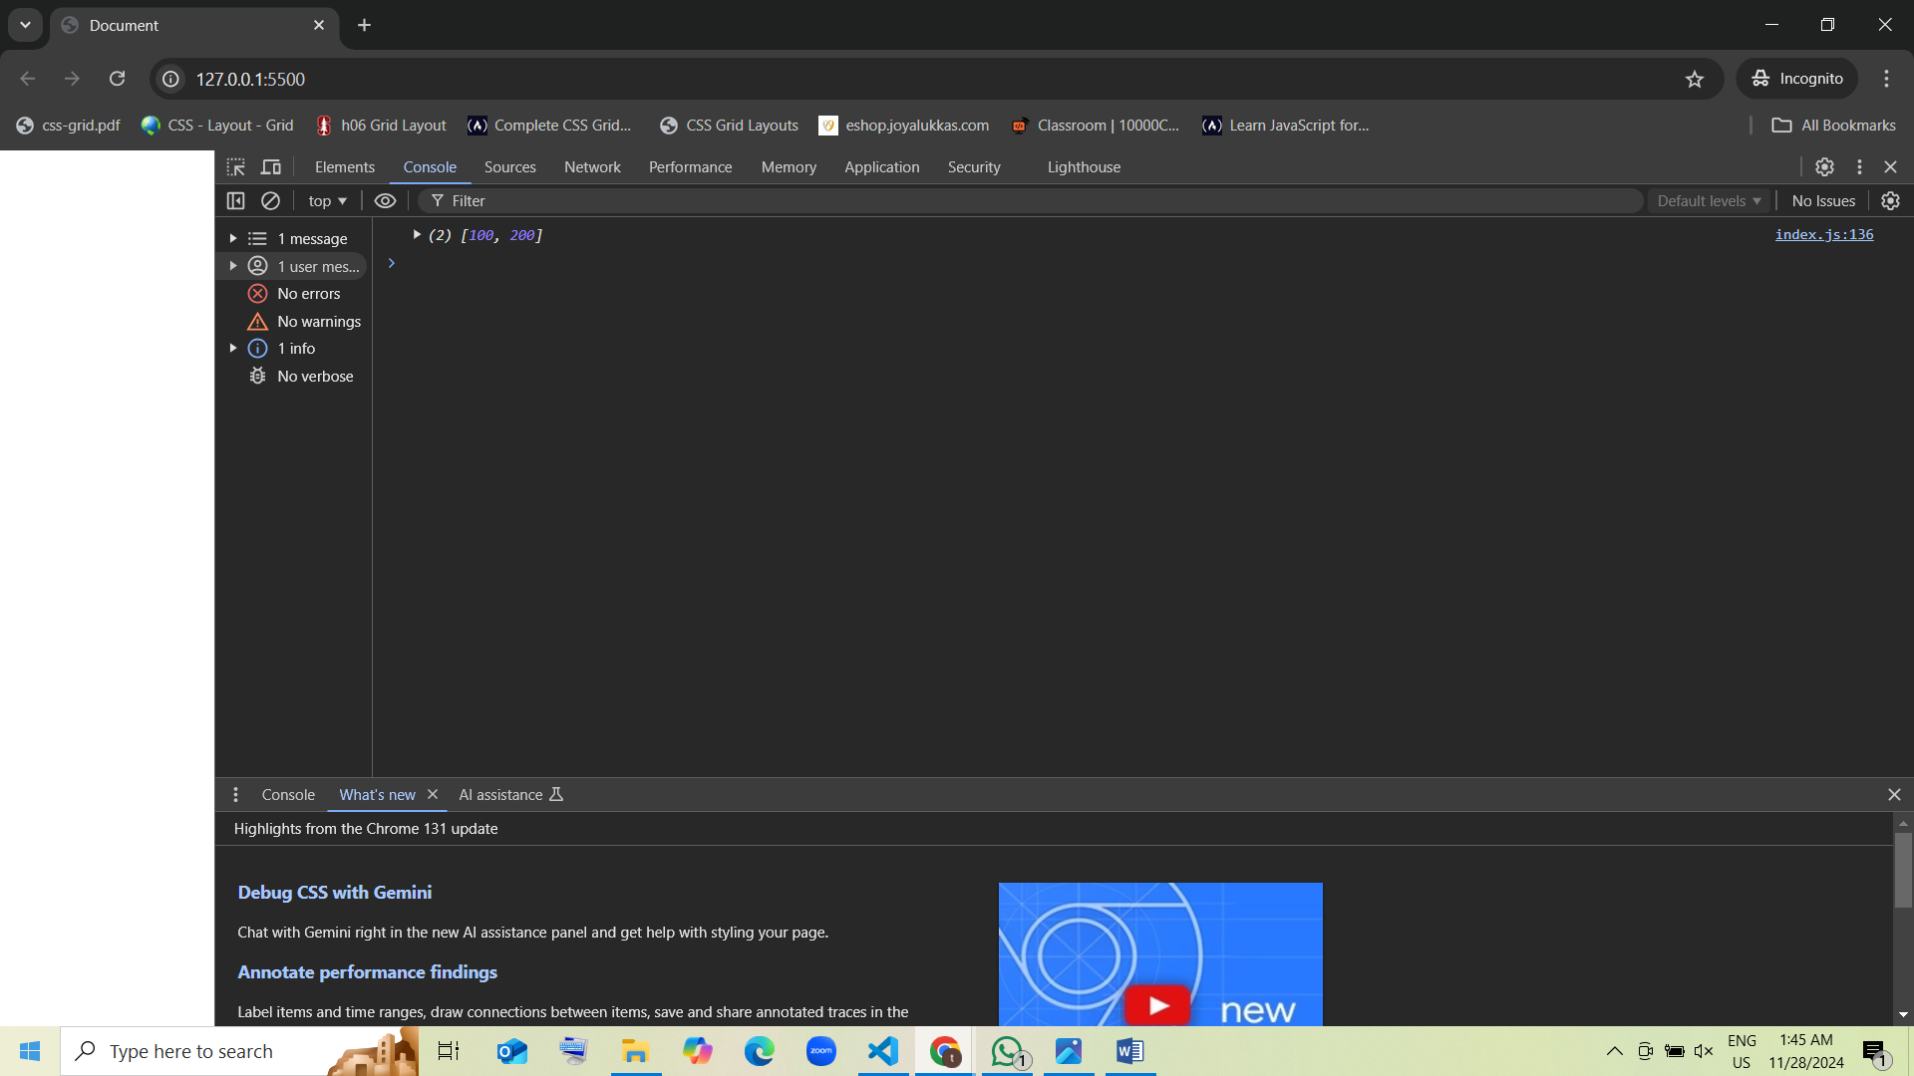

1. Guess the output:

* var value = [1, 2, 3];  
  var isArray = Array.isArray(value);  
  console.log(isArray);
  + 1. true guess [correct]
    2. false
    3. undefined
    4. Error

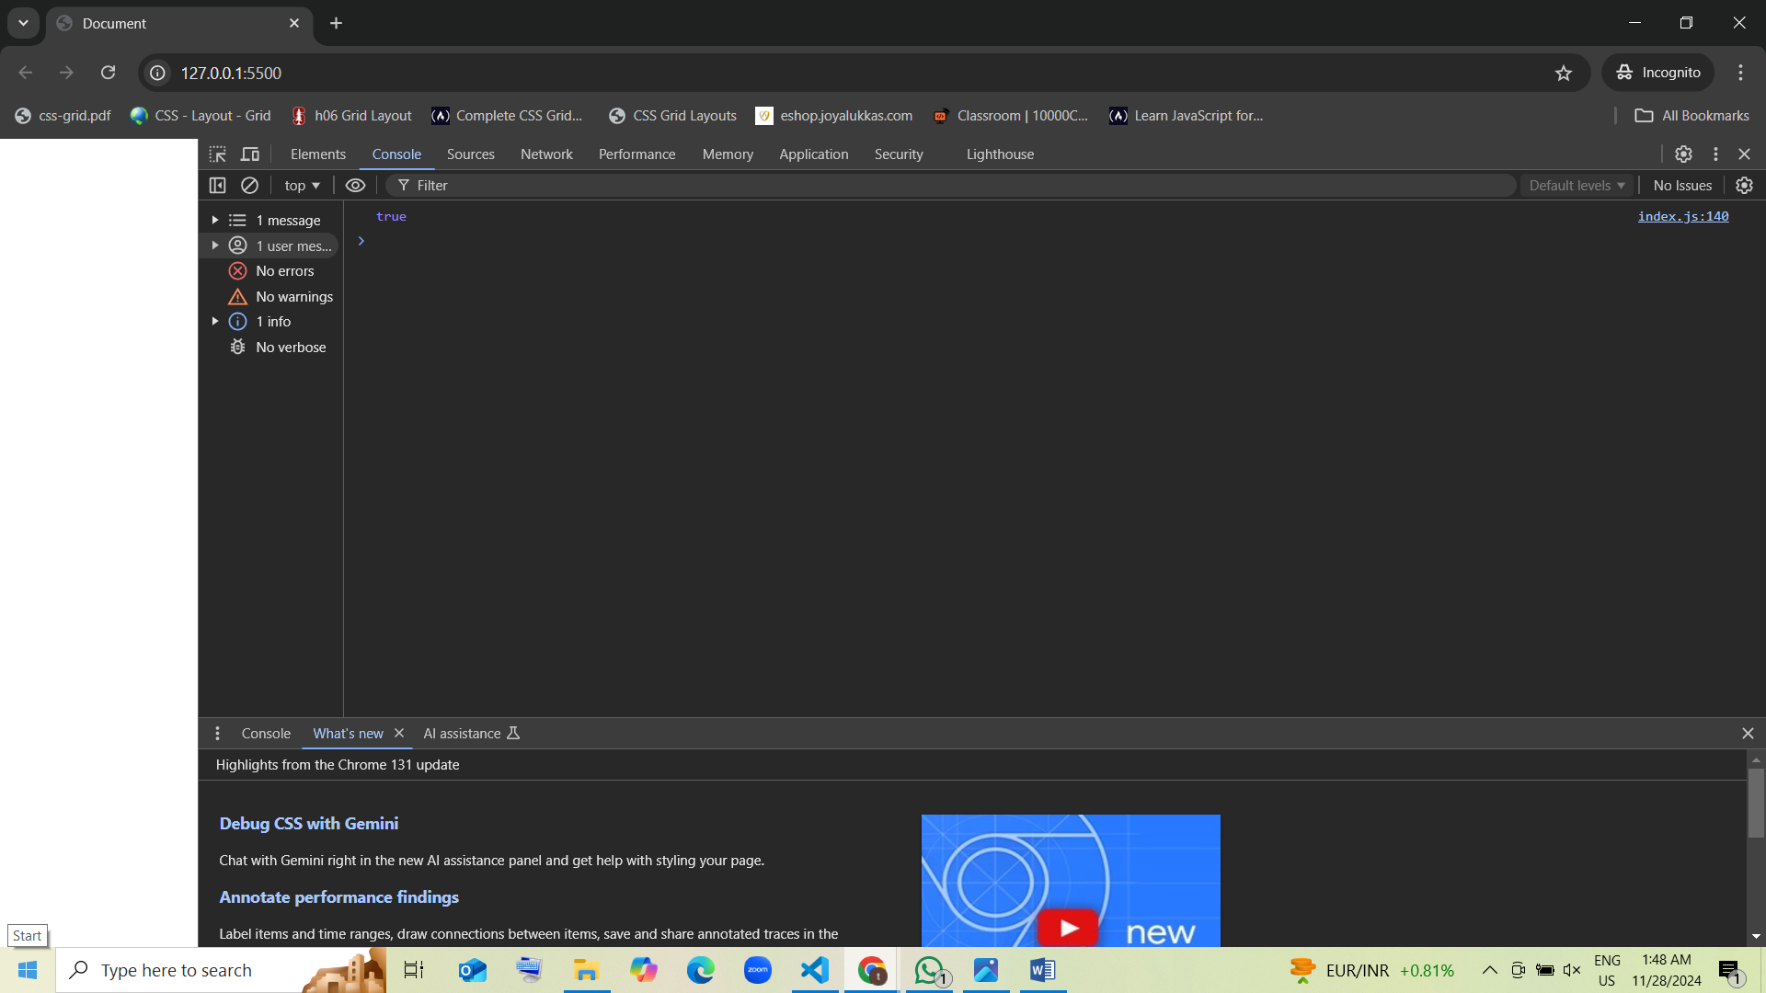

1. Guess the output:

* var arr1 = [1, 2];  
  var arr2 = [3, 4];  
  var result = arr1.concat(arr2); concat means combined two strings  
  console.log(result);
  + 1. [1, 2, 3, 4] guess [correct]
    2. [1, 2], [3, 4]
    3. [3, 4, 1, 2]
    4. Error

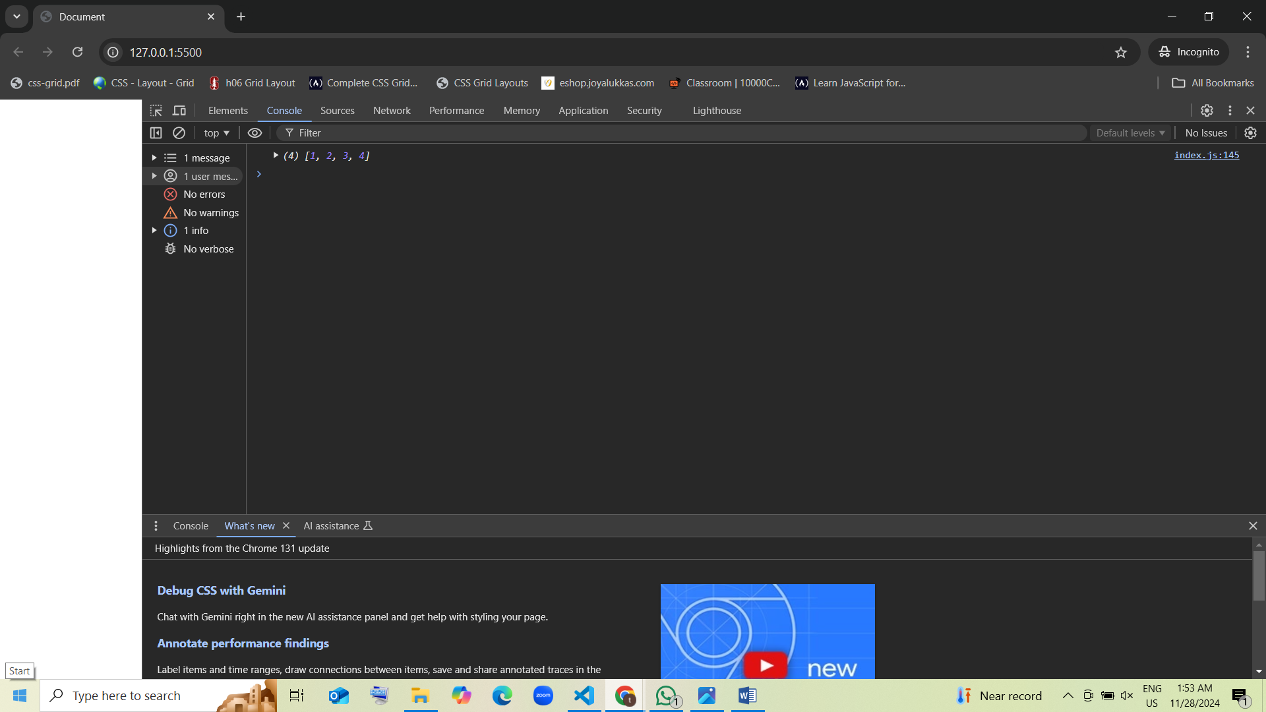

1. Guess the output:

* var letters = ["a", "b", "c"];  
  var count = letters.push("d", "e");  
  console.log(letters, count);
  + 1. ["a", "b", "c", "d", "e"], 5 guess [correct]
    2. ["a", "b", "c"], 3
    3. ["a", "b", "c", "d"], 4
    4. Error

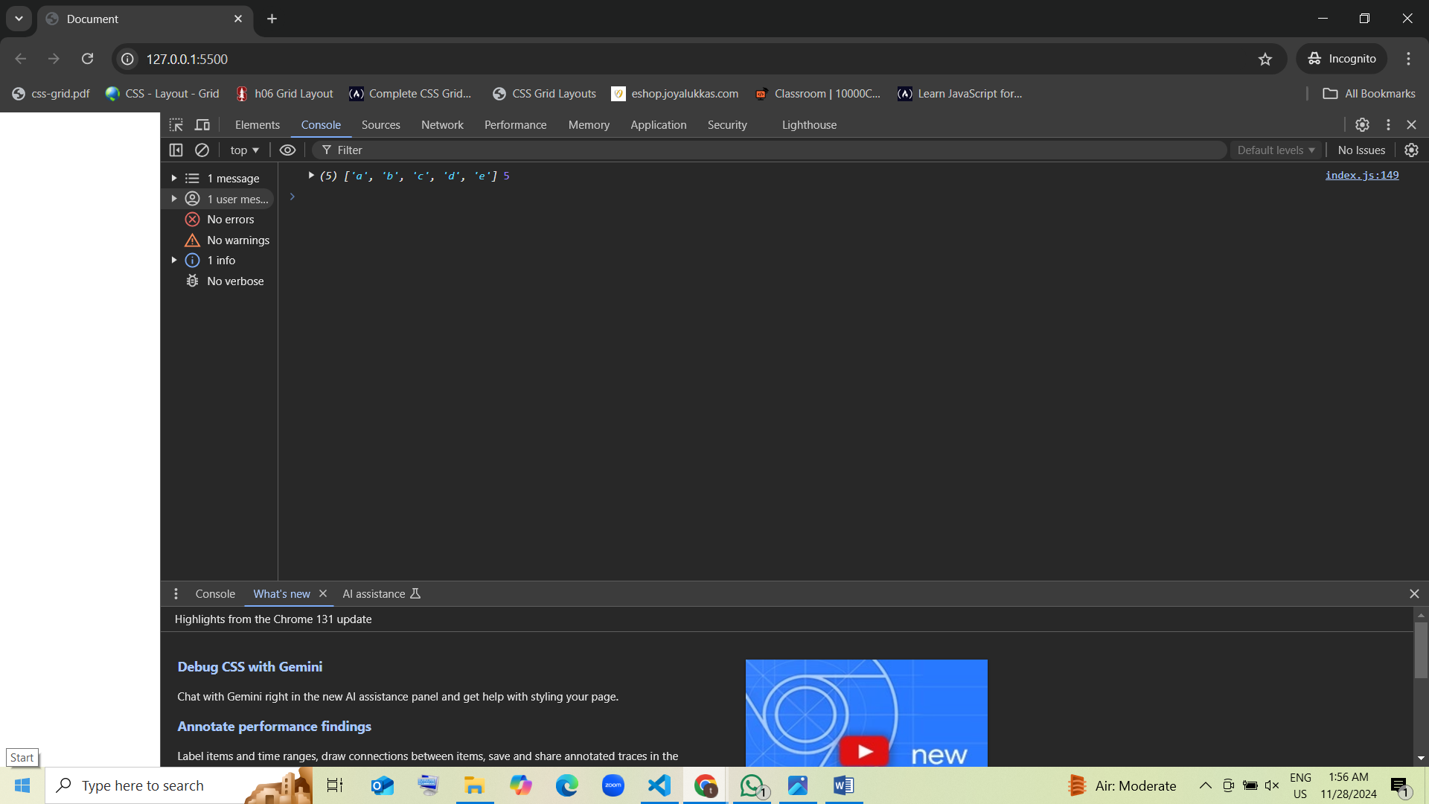

1. Guess the output:

* var nums = [1, 2, 3, 4];  
  nums.pop();  
  nums.shift();  
  console.log(nums);
  + 1. [1, 2, 3]
    2. [2, 3] guess [correct]
    3. [3, 4]
    4. Error

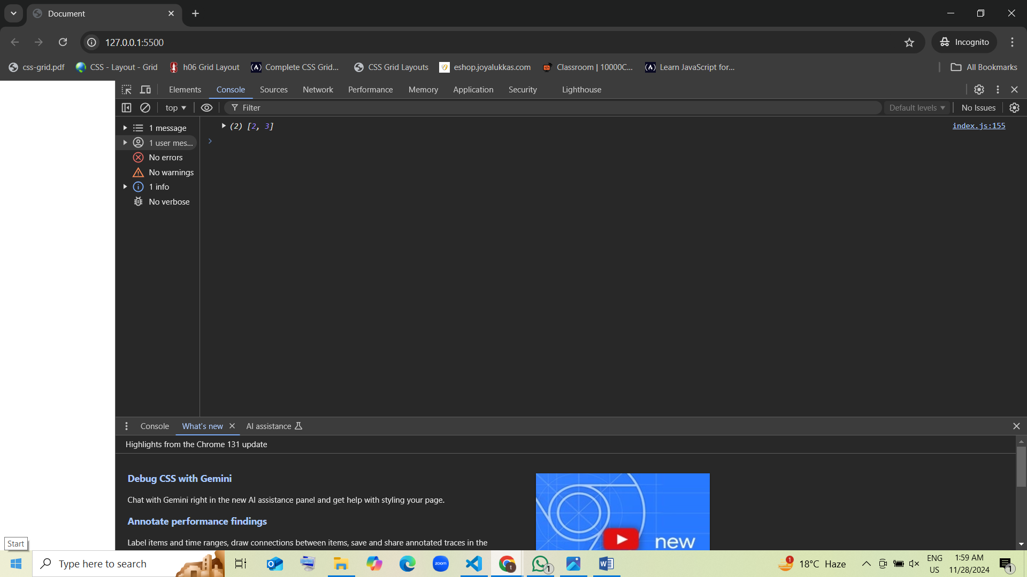

1. Guess the output:

var arr = [1, 2, 3];  
var length = arr.unshift(0);  
arr.pop();  
console.log(arr, length);

* 1. [0, 1, 2], 4 guess [correct]
  2. [0, 2], 3
  3. [0, 1], 2
  4. Error

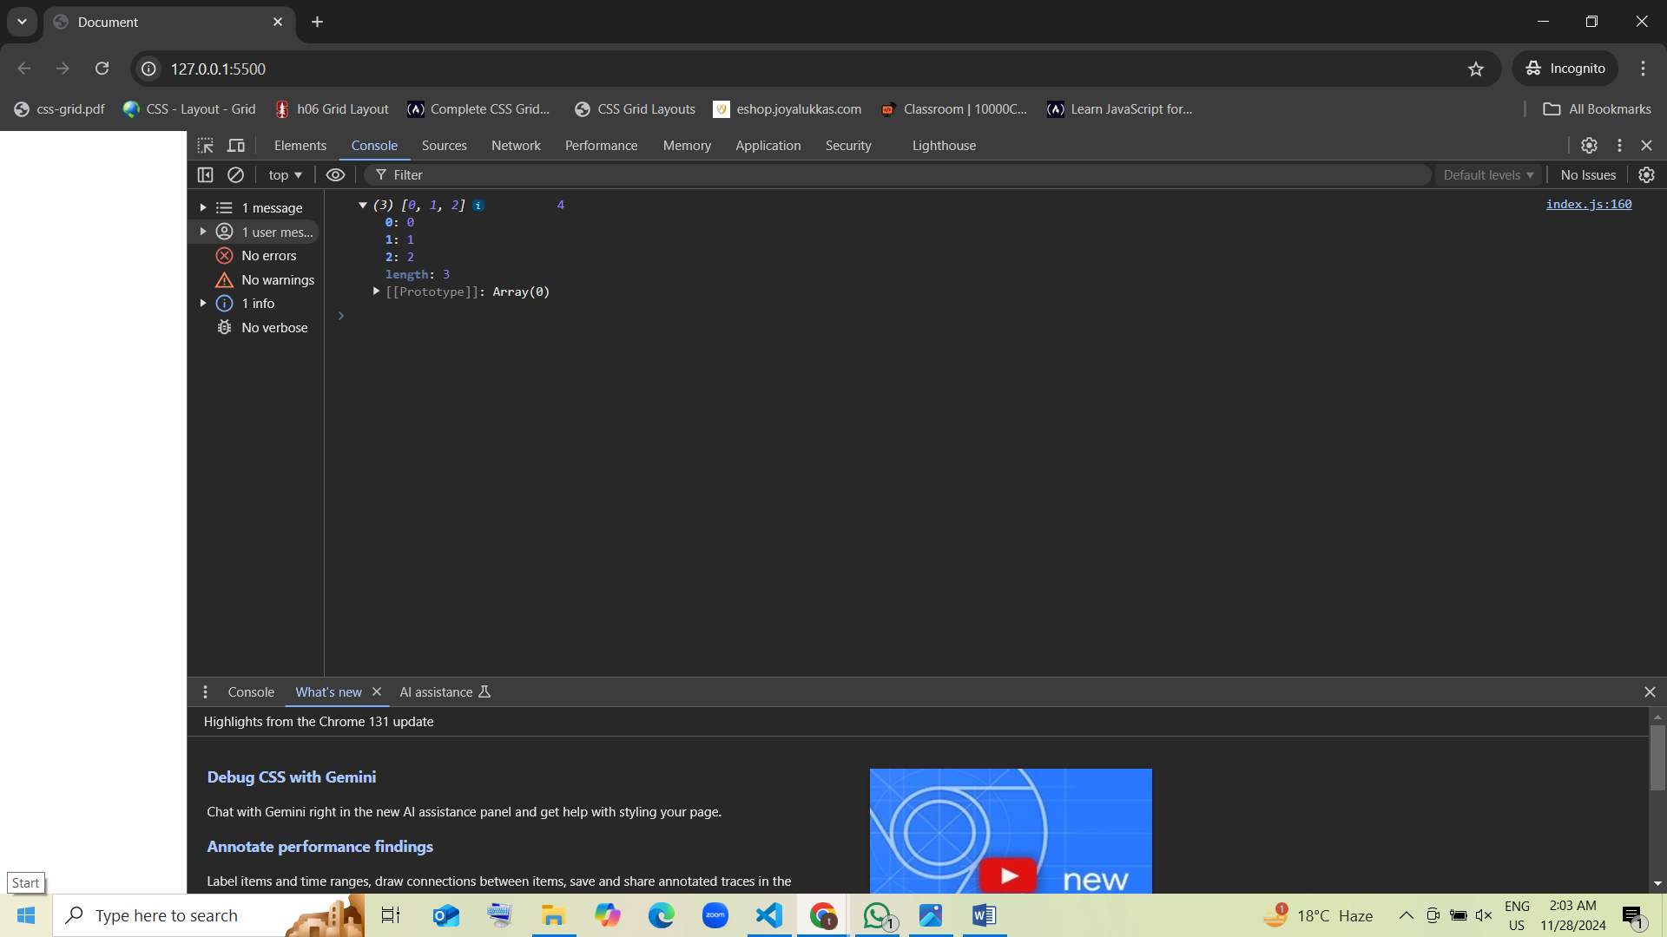

1. Guess the output:

var items = ["pen", "pencil", "eraser"];  
var length = items.push("sharpener");  
console.log(items, length);

* 1. ["pen", "pencil", "eraser", "sharpener"], 4 guess [correct]
  2. ["pen", "pencil", "eraser"], 3
  3. ["sharpener", "pen", "pencil", "eraser"], 4
  4. Error

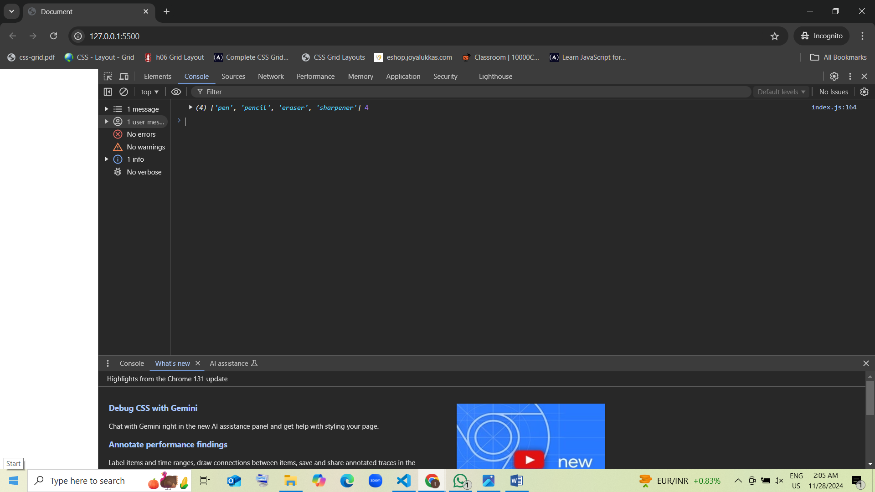

1. Guess the output:

var nums = [10, 20, 30];  
nums.length = 5;  
console.log(nums);

* 1. [10, 20, 30, undefined, undefined] guess [correct]
  2. [10, 20, 30]
  3. [10, 20, 30, 0, 0]
  4. Error

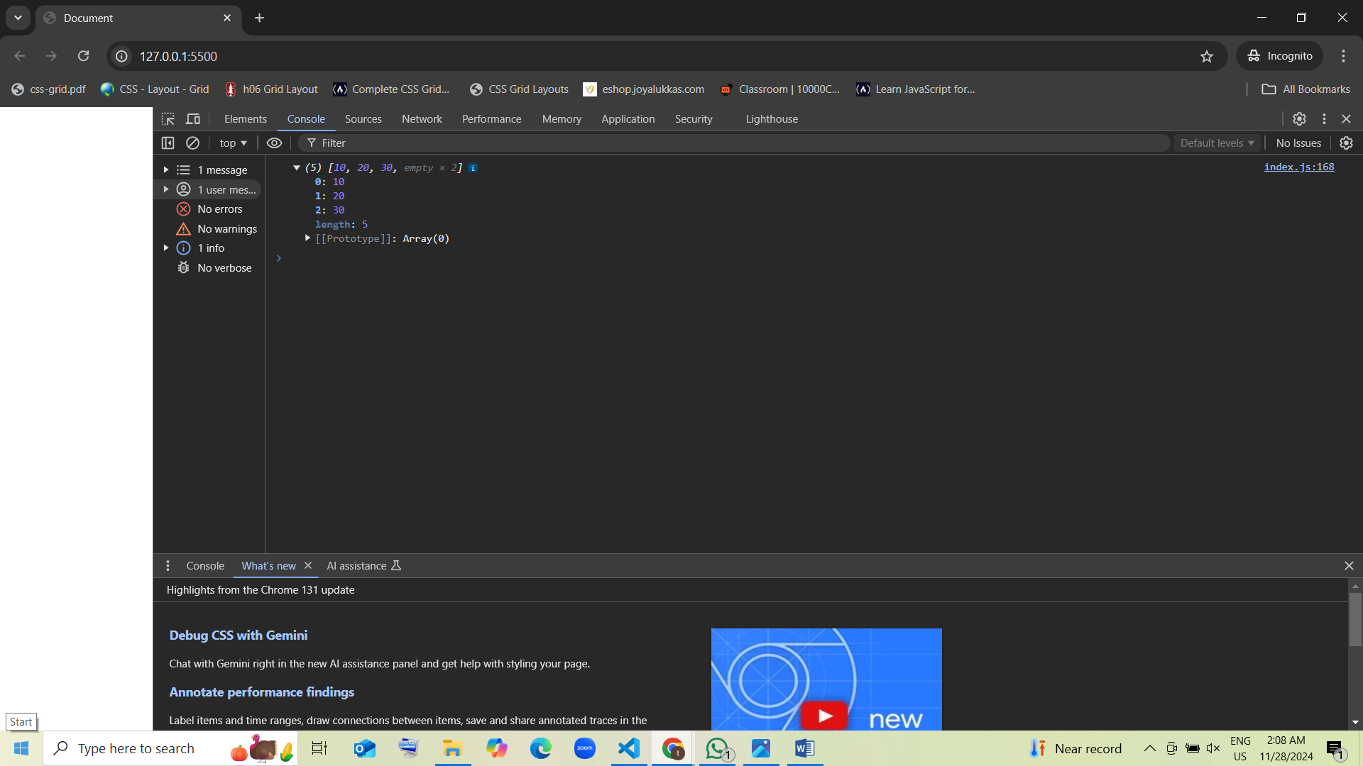

1. Guess the output:

var fruits = ["mango", "apple"];  
fruits.shift();  
fruits.push("orange");  
console.log(fruits);

* 1. ["apple", "orange"] guess [correct]
  2. ["mango", "apple", "orange"]
  3. ["orange"]
  4. Error

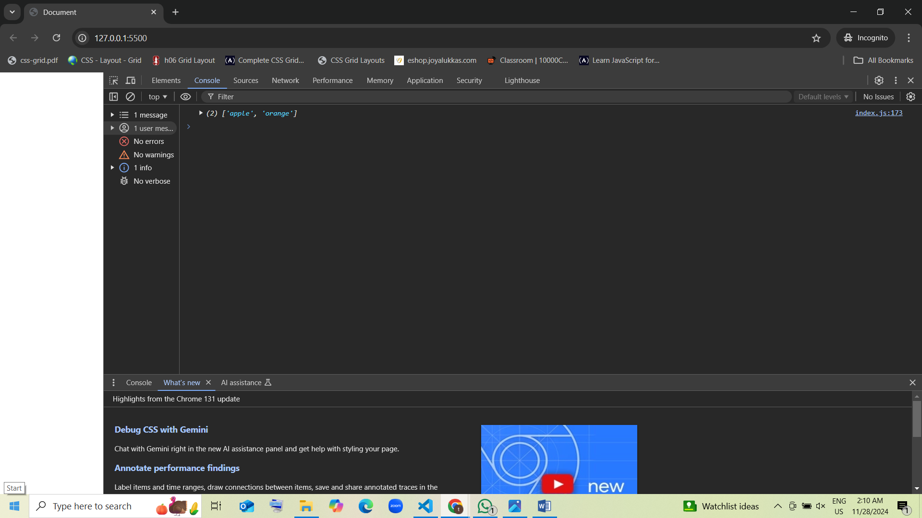

1. Guess the output:

var arr = [1, 2, 3];  
arr.pop();  
arr.unshift(0);  
console.log(arr);

* 1. [0, 1, 2] guess [correct]
  2. [0, 2]
  3. [1, 2, 3]
  4. Error

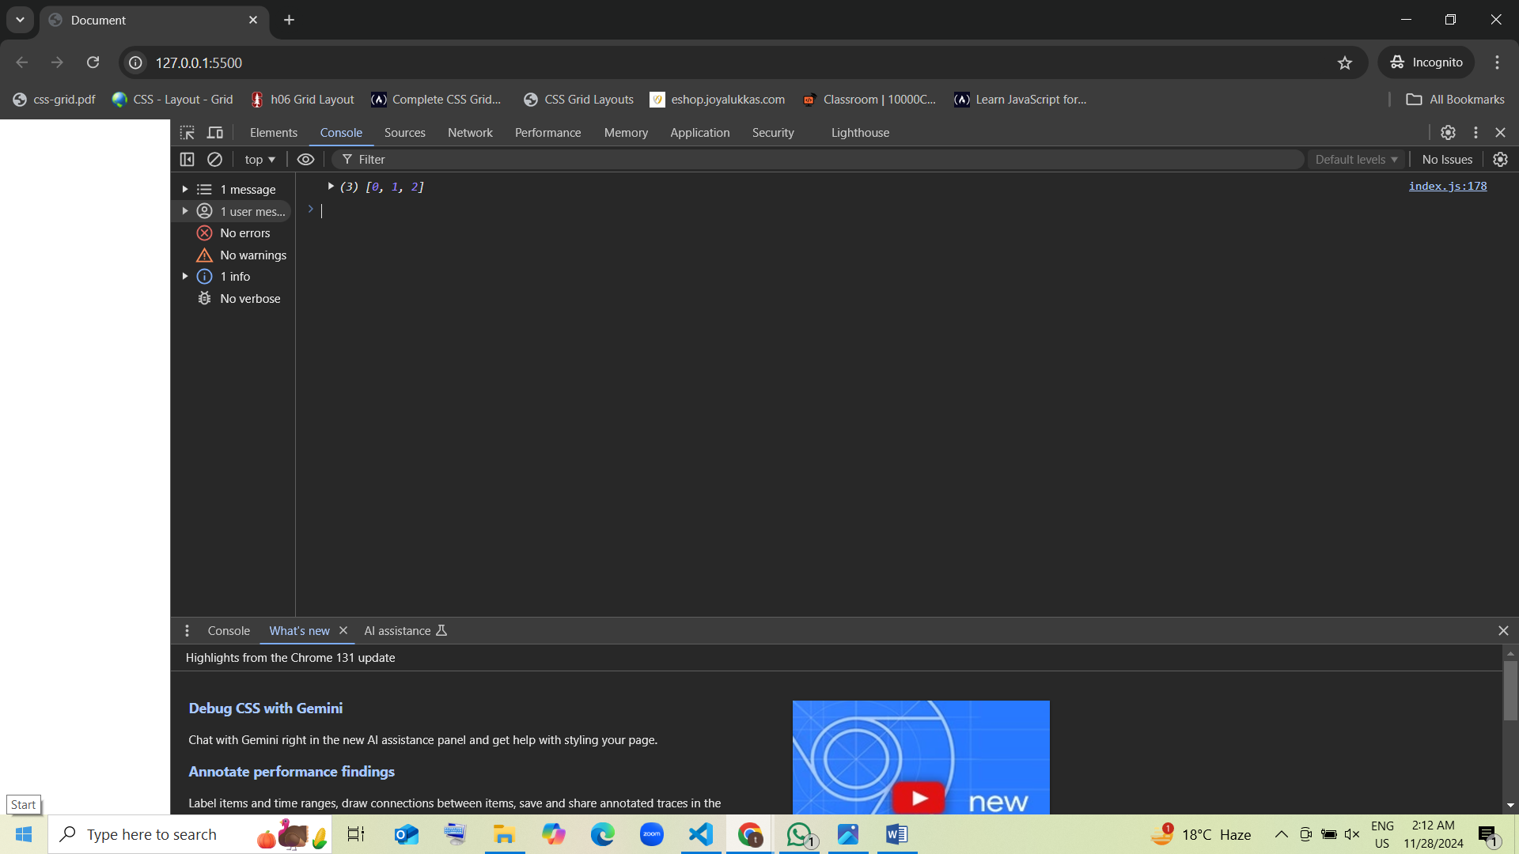

1. Guess the output:

var letters = ["x", "y"];  
letters.unshift("w");  
letters.push("z");  
console.log(letters);

* 1. ["w", "x", "y", "z"] guess [correct]
  2. ["x", "y", "z", "w"]
  3. ["w", "z"]
  4. Error

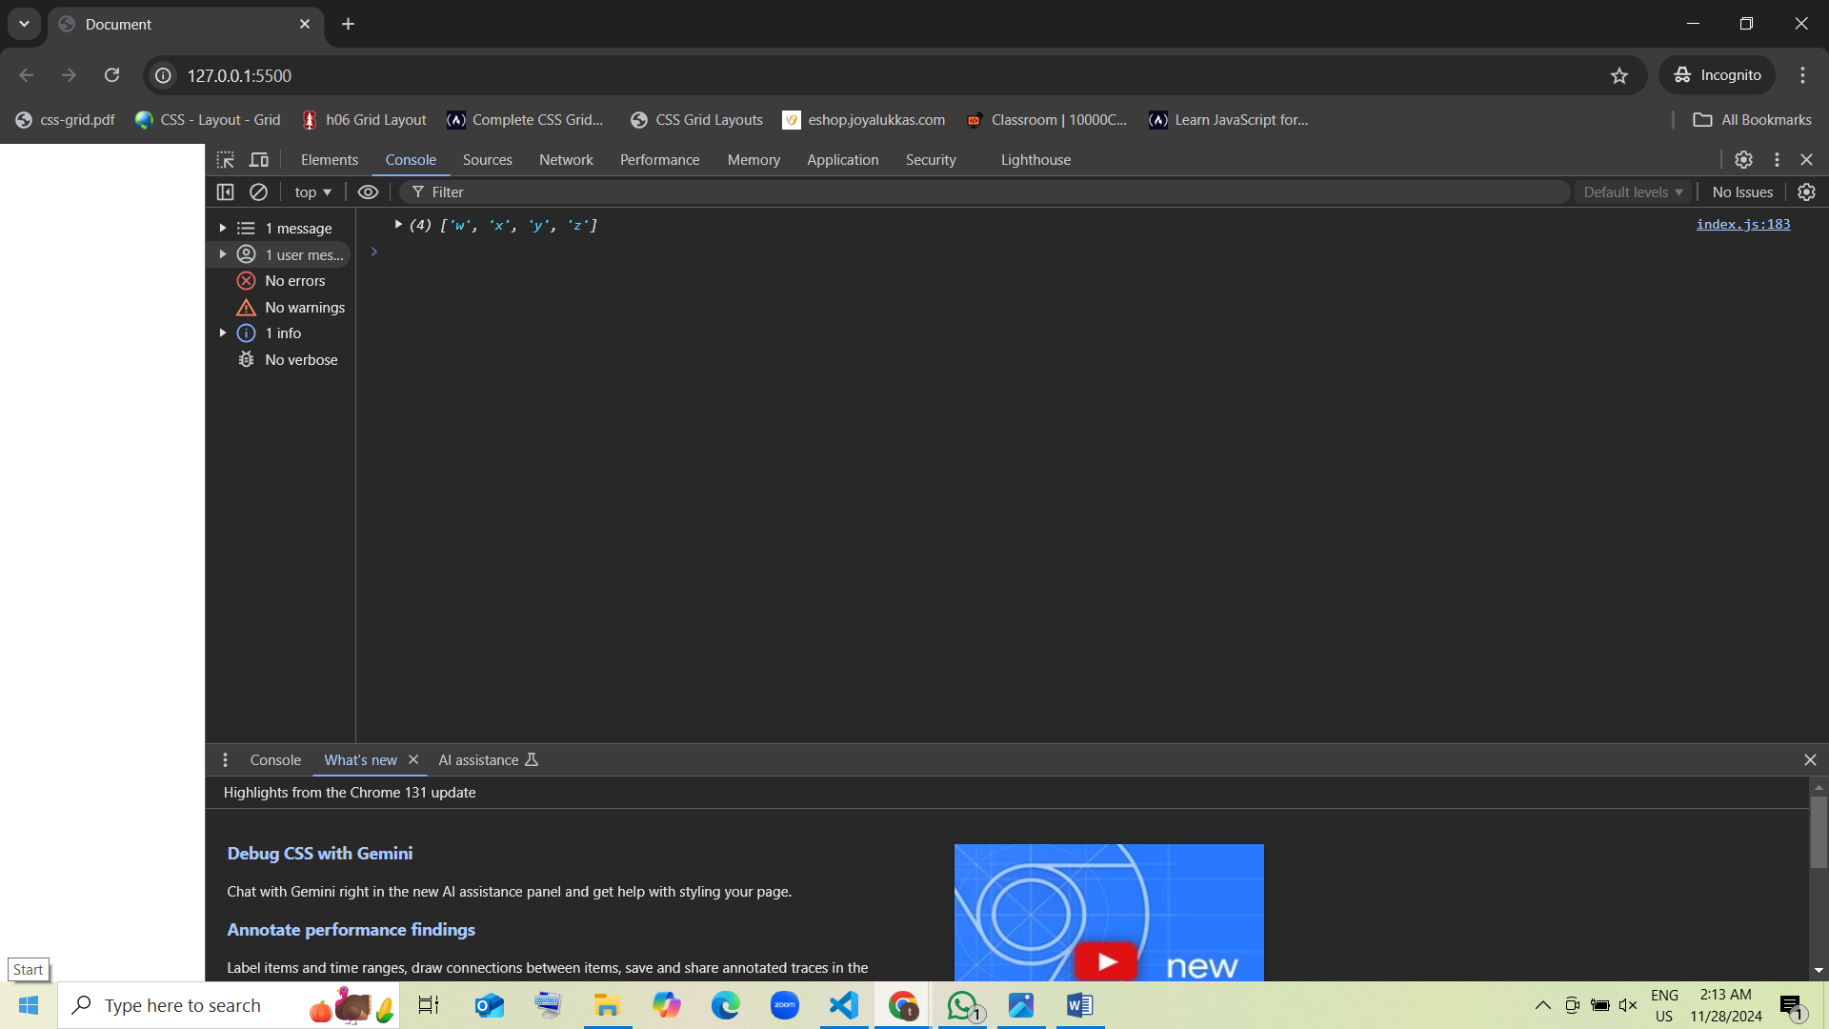

1. Guess the output:

var values = [];  
values.push(1);  
values.pop();  
console.log(values);

* 1. [] guess [correct]
  2. [1]
  3. [undefined]
  4. Error

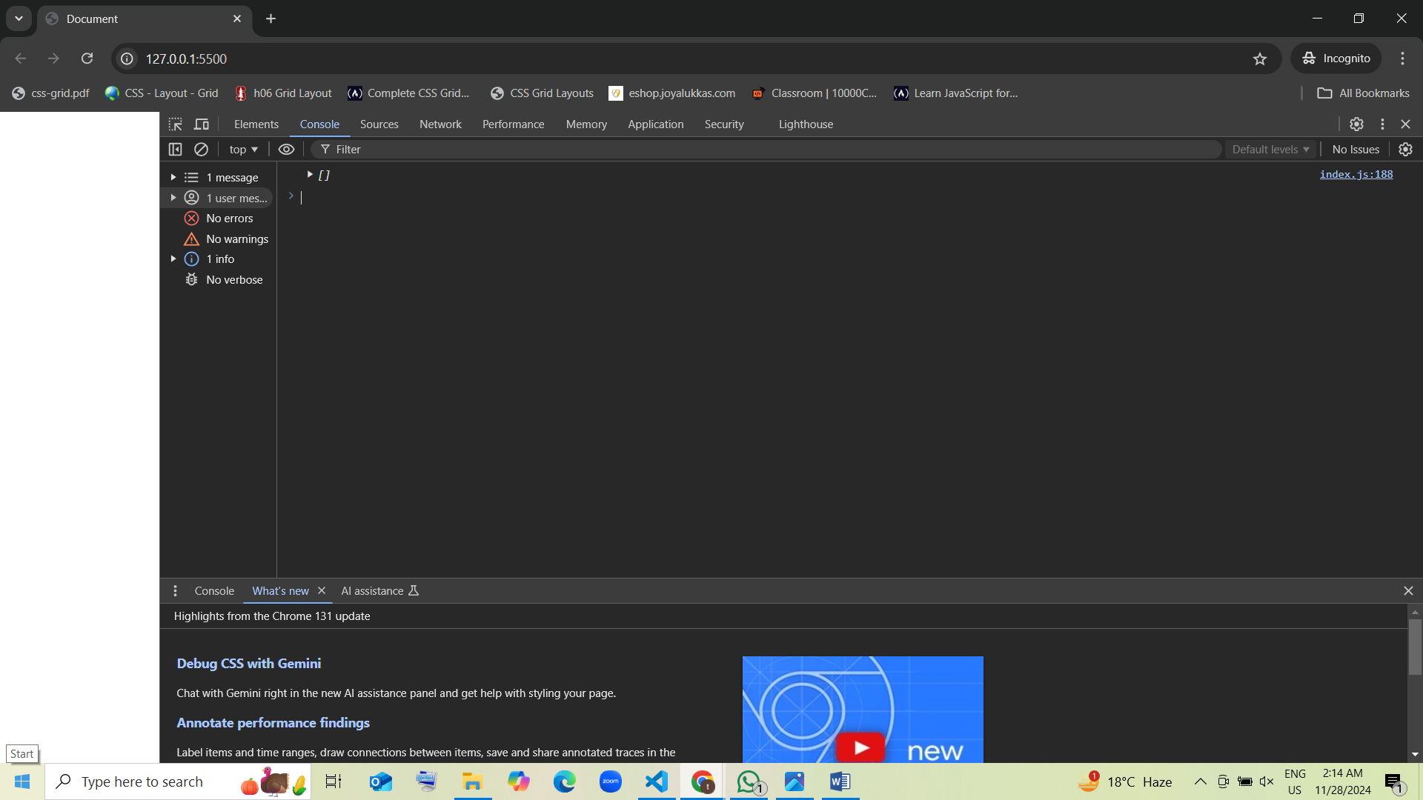

1. Guess the output:

var nums = [100];  
nums.unshift(50);  
nums.pop();  
console.log(nums);

* 1. [50] guess [correct]
  2. [100, 50]
  3. []
  4. Error

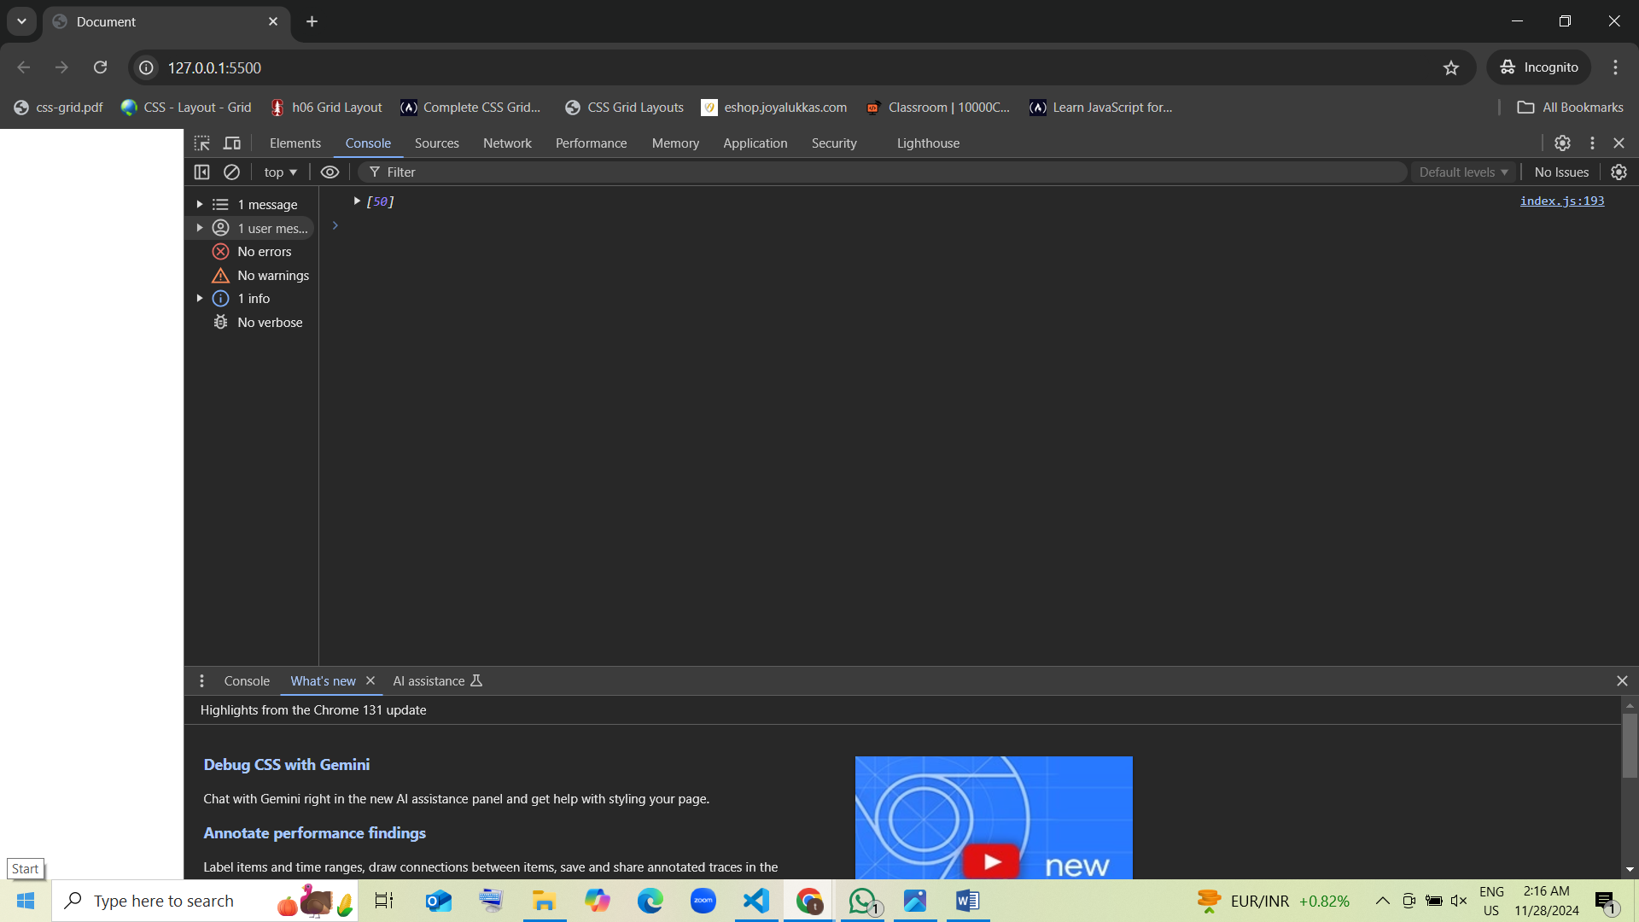

1. Guess the output:

var arr1 = ["a"];  
var arr2 = ["b", "c"];  
var combined = arr1.concat(arr2);  
console.log(combined);

* 1. ["a", "b", "c"] guess [correct]
  2. [["a"], ["b", "c"]]
  3. [["a"], "b", "c"]
  4. Error

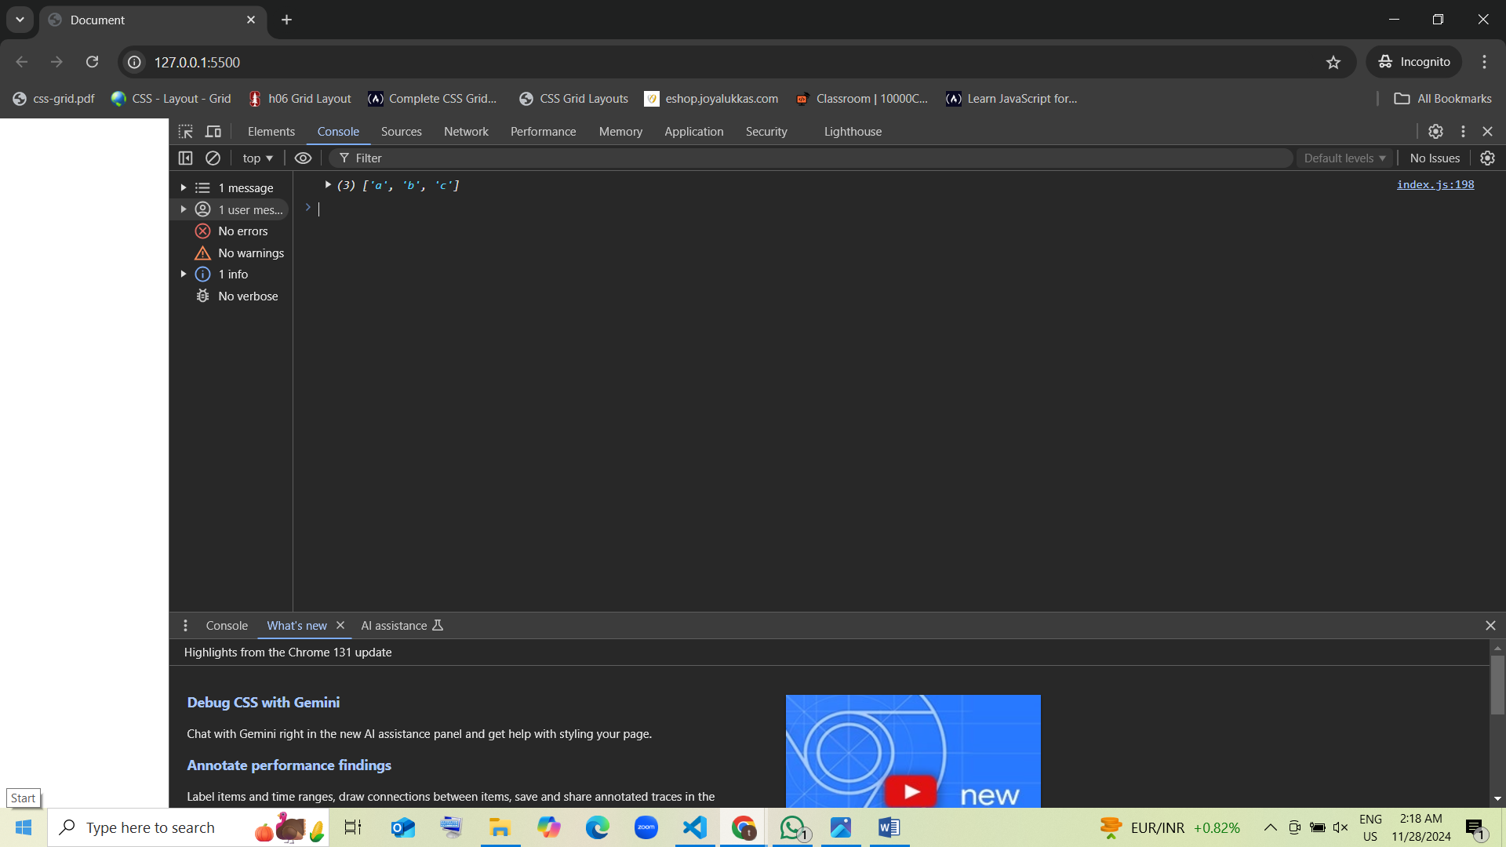

1. Guess the output:

var nums = [5, 10];  
nums.push(15);  
nums.shift();  
console.log(nums);

* 1. [10, 15] guess [correct]
  2. [5, 10]
  3. [5]
  4. Error

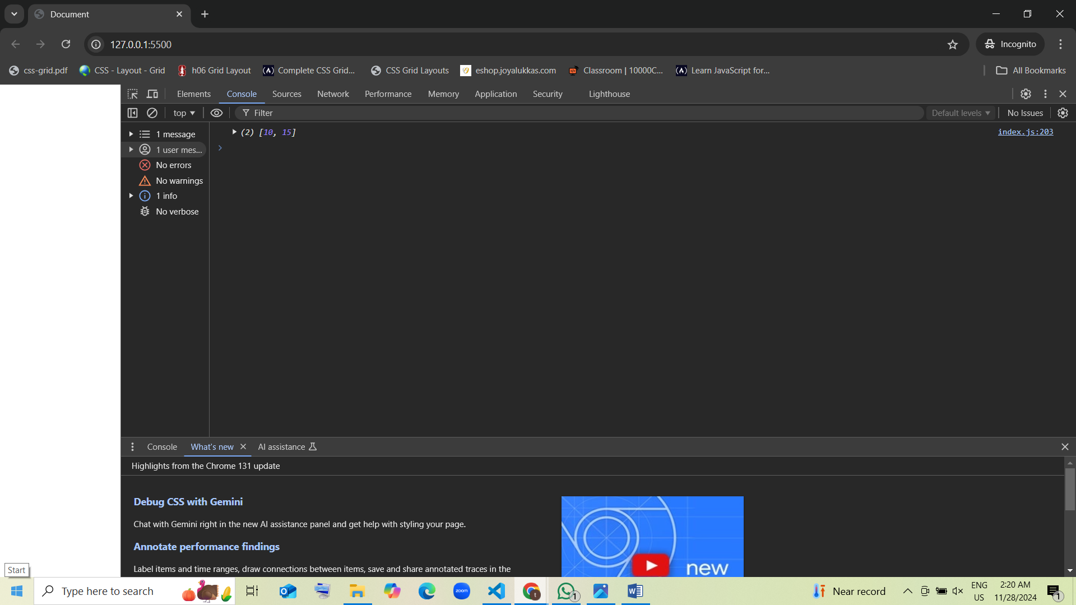

1. Guess the output:

var data = ["x", "y"];  
data.unshift("z");  
data.pop();  
console.log(data);

* 1. ["z", "x"] guess [correct]
  2. ["z", "y"]
  3. ["x"]
  4. Error

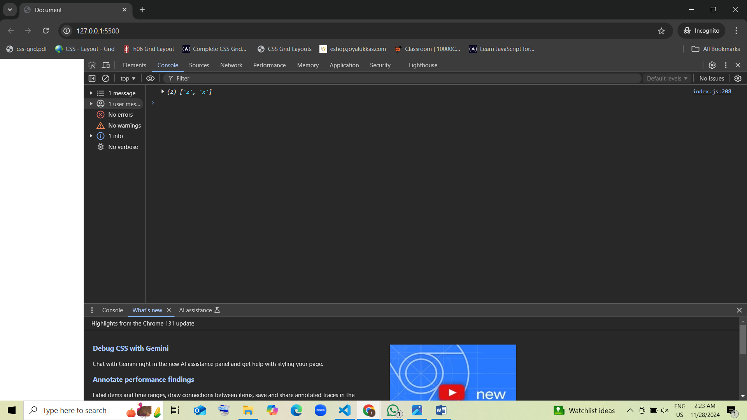

1. Guess the output:

var arr = [];  
arr.push(1, 2);  
arr.pop();  
console.log(arr);

* 1. [1] guess [correct]
  2. [1, 2]
  3. []
  4. Error

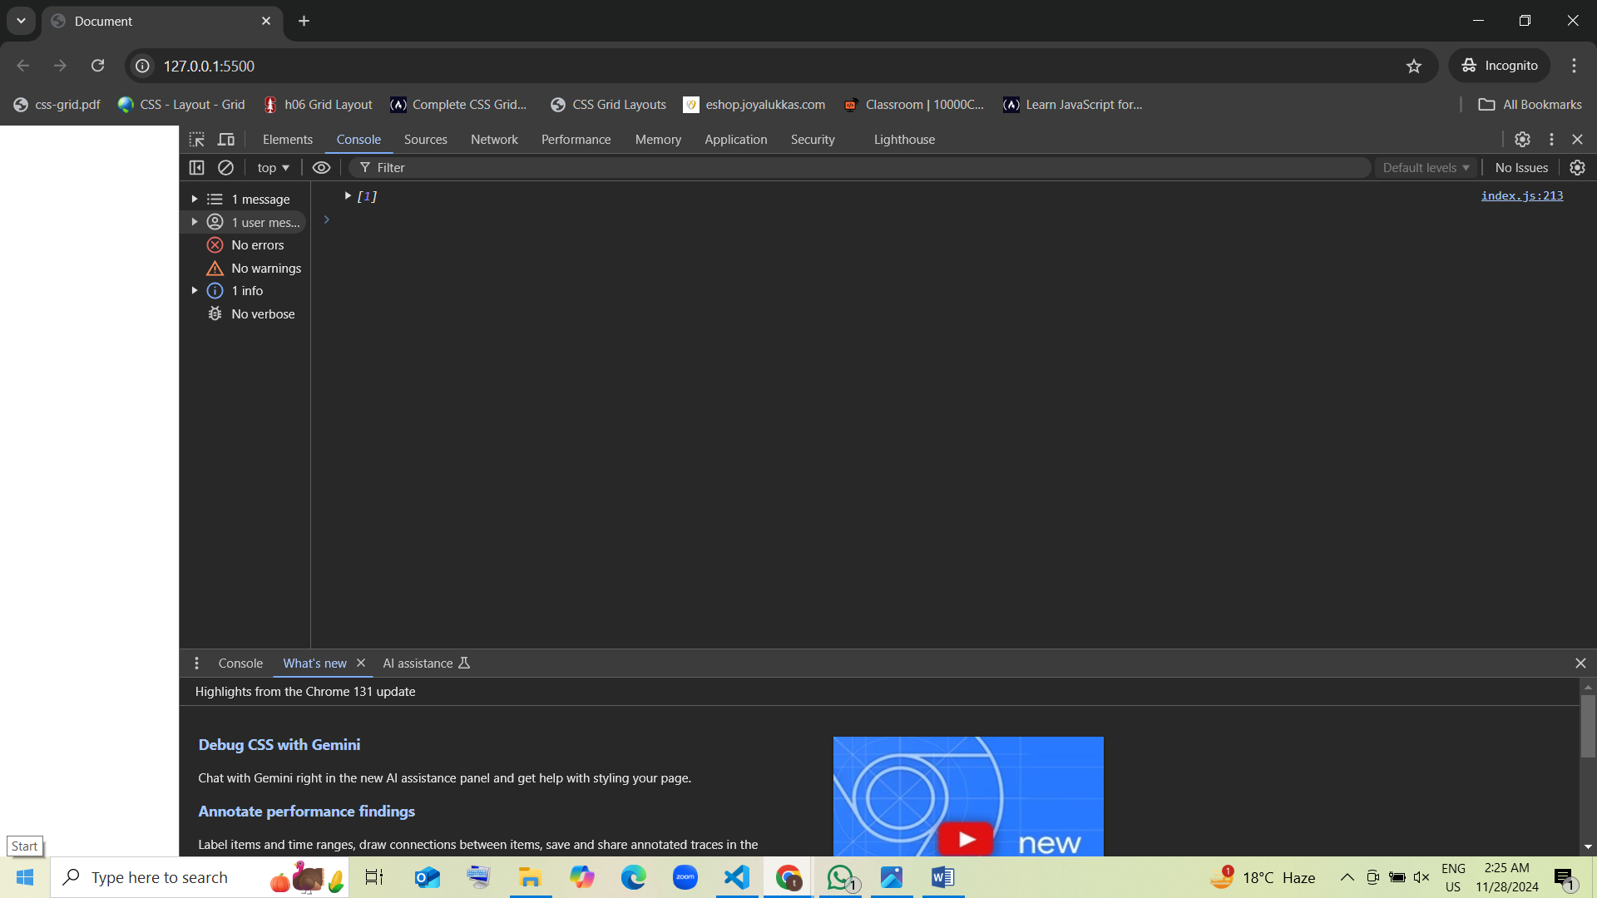

1. Guess the output:

var arr = ["a", "b", "c"];  
arr.pop();  
arr.push("d");  
console.log(arr);

* 1. ["a", "b", "d"] guess [correct]
  2. ["d", "b", "c"]
  3. ["a", "b", "c", "d"]
  4. Error

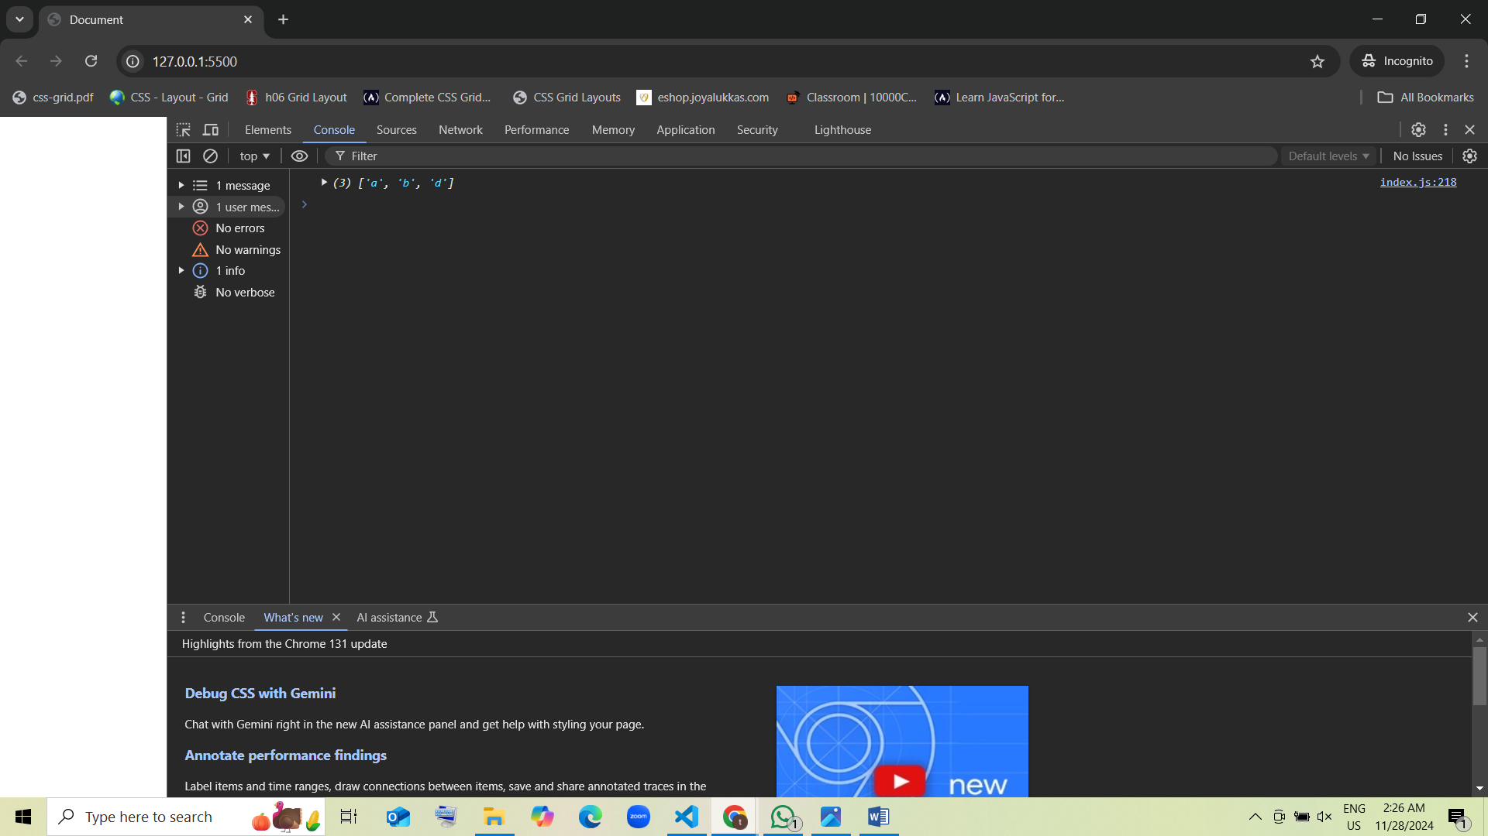

1. Guess the output:

var arr = ["x"];  
arr.unshift("y");  
arr.push("z");  
arr.shift();  
console.log(arr);

* 1. ["x", "z"] guess [correct]
  2. ["y", "z"]
  3. ["z"]
  4. Error

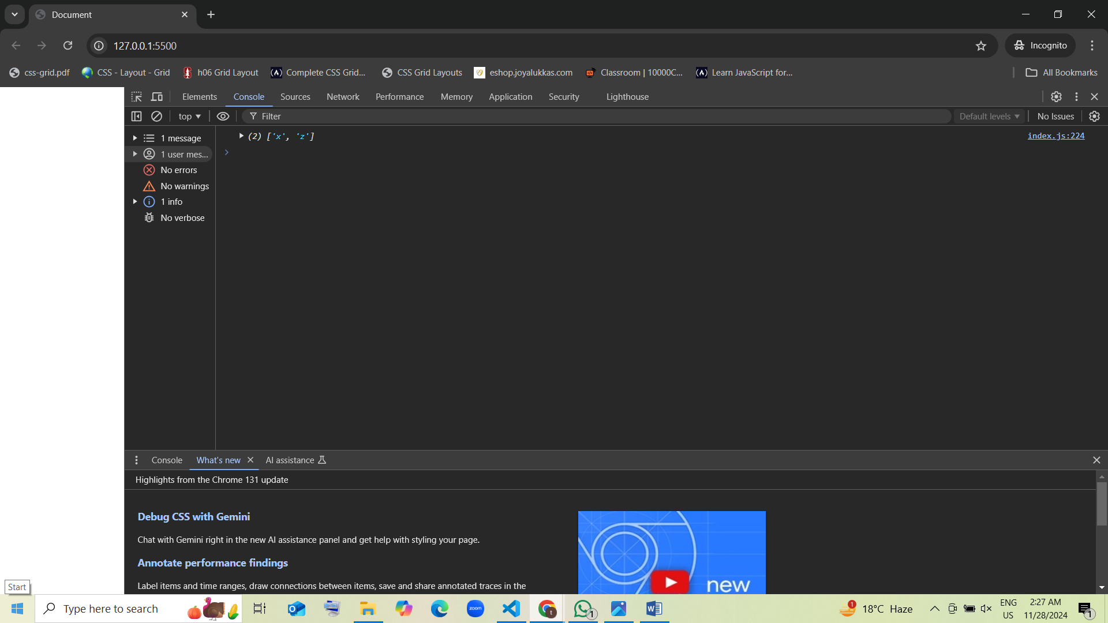

1. Guess the output:

var arr = ["1"];  
arr.unshift("2", "3");  
console.log(arr);

* 1. ["2", "3", "1"] guess [correct]
  2. ["1", "2", "3"]
  3. [1, 2, 3]
  4. Error

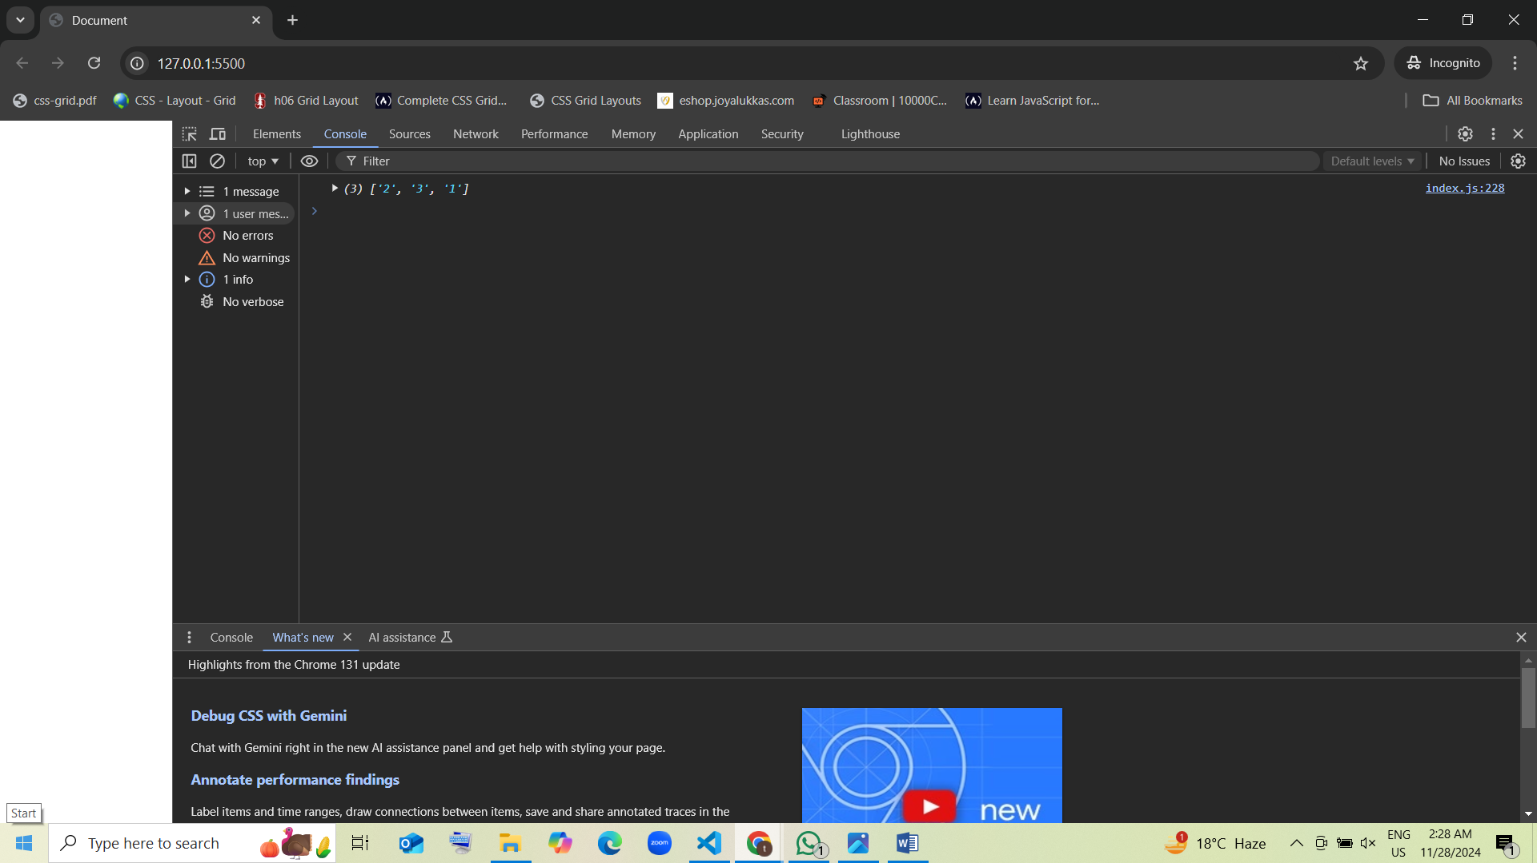

1. Guess the output:

var arr = [10];  
arr.push(20, 30);  
arr.shift();  
console.log(arr);

* 1. [20, 30] guess [correct]
  2. [10, 20]
  3. [10, 20, 30]
  4. Error

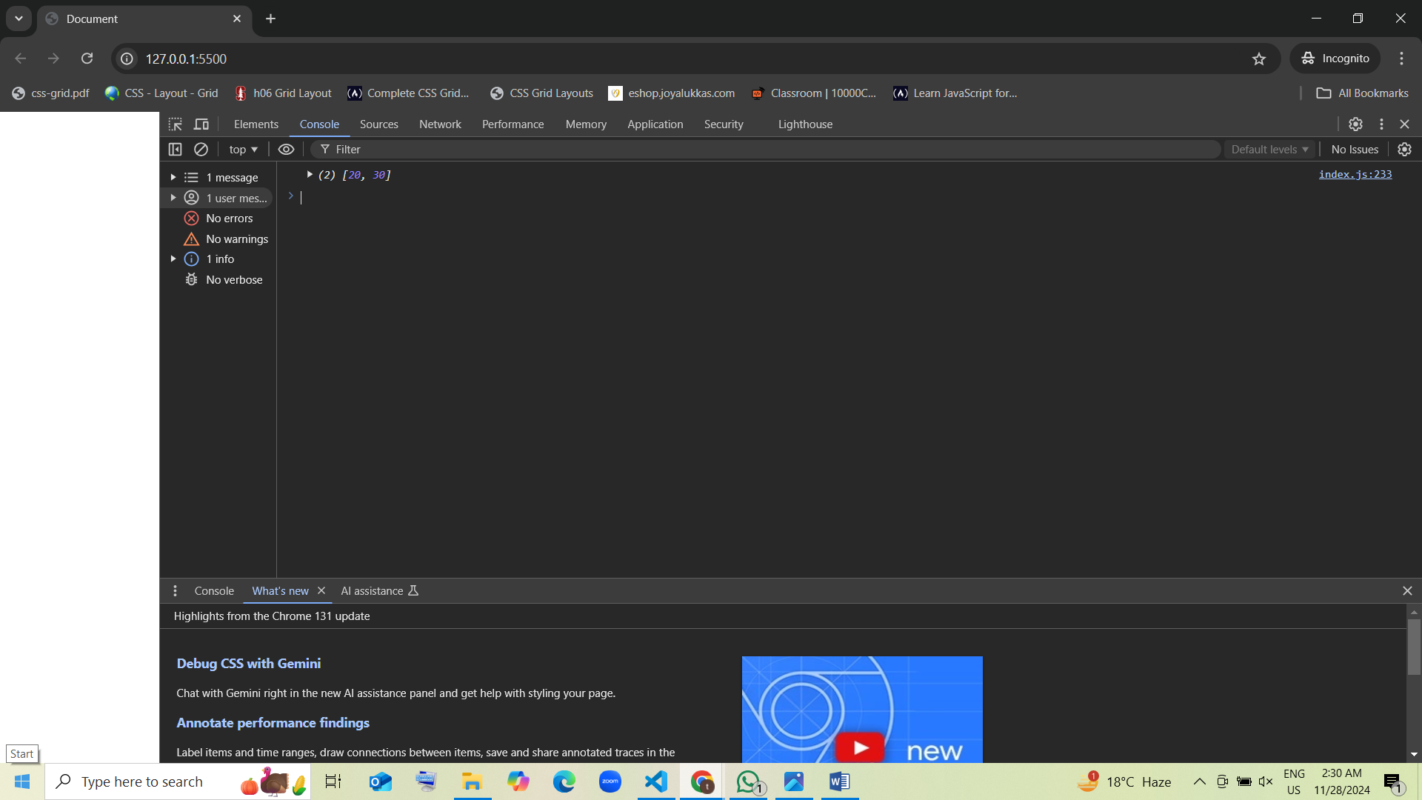

1. Guess the output:

var arr = [];  
arr.unshift("a");  
arr.push("b");  
arr.unshift("c");  
console.log(arr);

* 1. ["c", "a", "b"] guess [correct]
  2. ["a", "b", "c"]
  3. ["a", "b"]
  4. Error

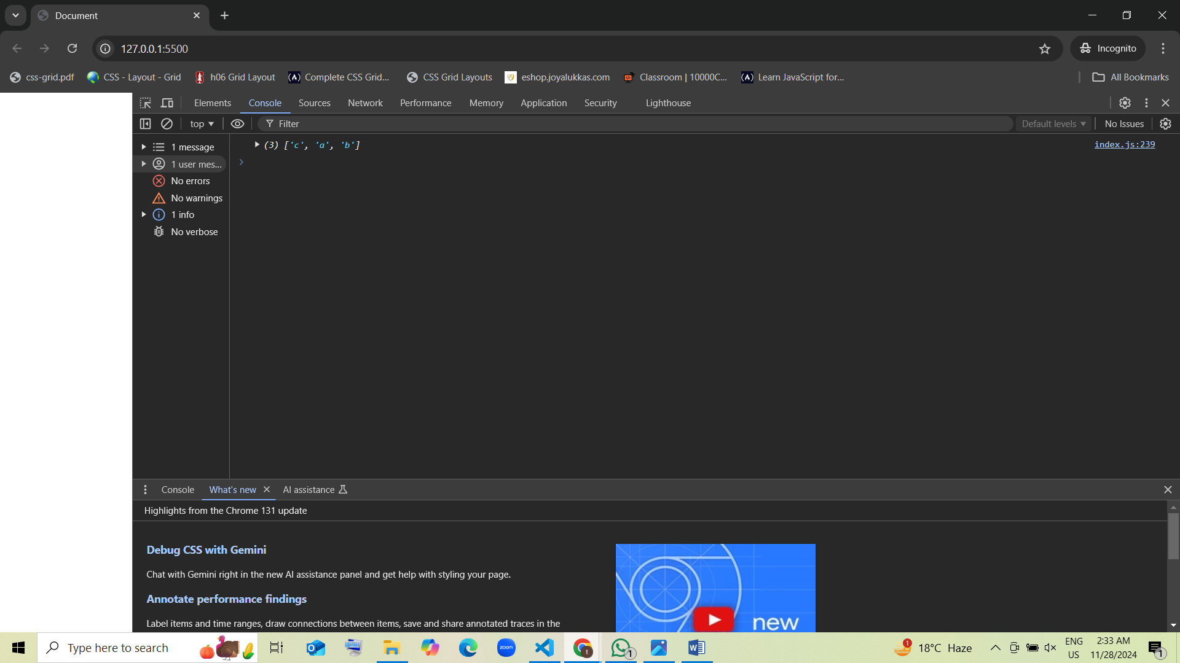

1. Guess the output:

var arr = ["1"];  
arr.pop();  
arr.unshift("2");  
console.log(arr);

* 1. ["2"] guess [correct]
  2. ["1"]
  3. ["2", "1"]
  4. Error

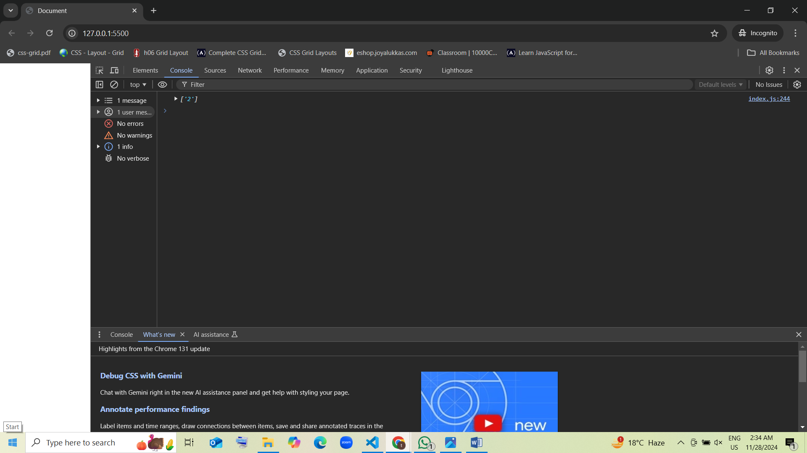

1. Guess the output:

var nums = [5];  
nums.push(10, 15);  
nums.length = 2;  
console.log(nums);

* 1. [5, 10] guess [correct]
  2. [5, 10, 15]
  3. [5]
  4. Error

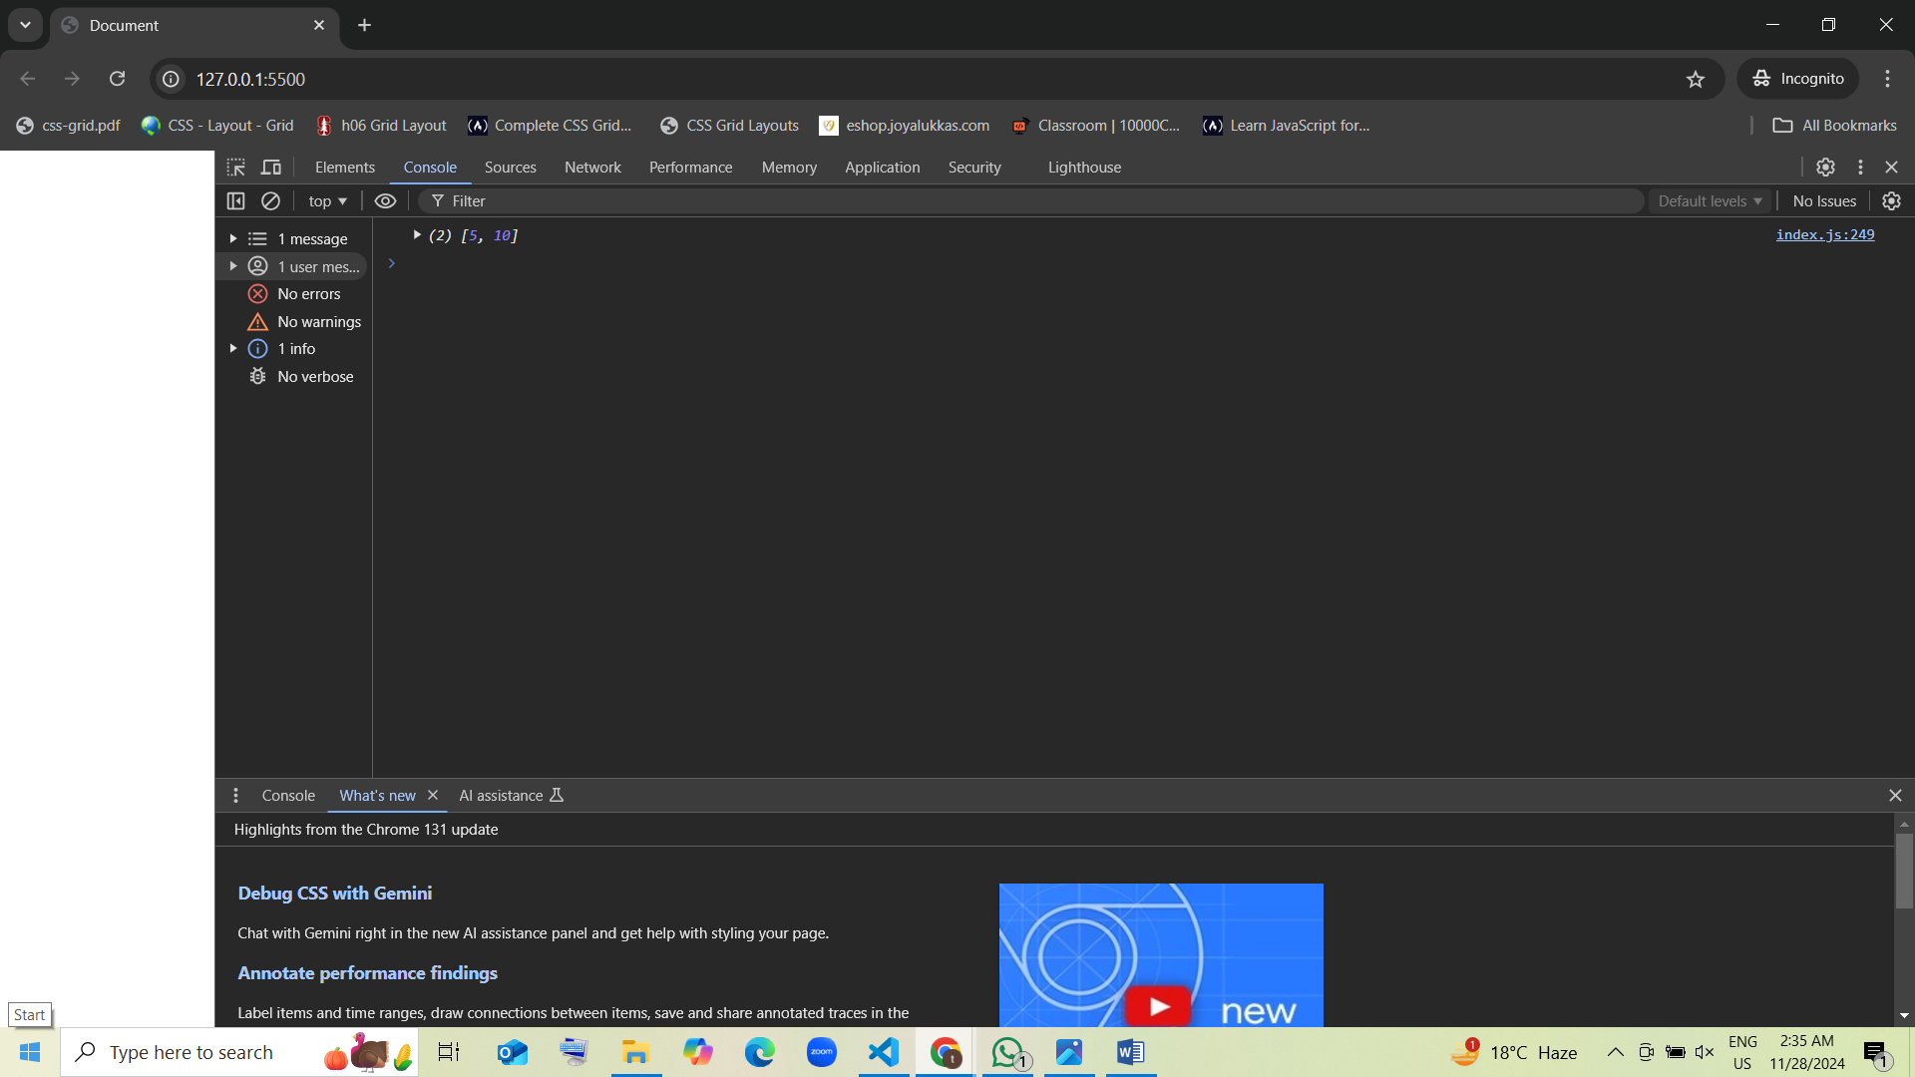

1. Guess the output:

var arr = ["a", "b", "c"];  
arr.pop();  
arr.length = 5;  
console.log(arr);

* 1. ["a", "b", undefined, undefined, undefined] guess [correct]
  2. ["a", "b", "c", undefined, undefined]
  3. ["a", "b"]
  4. Error

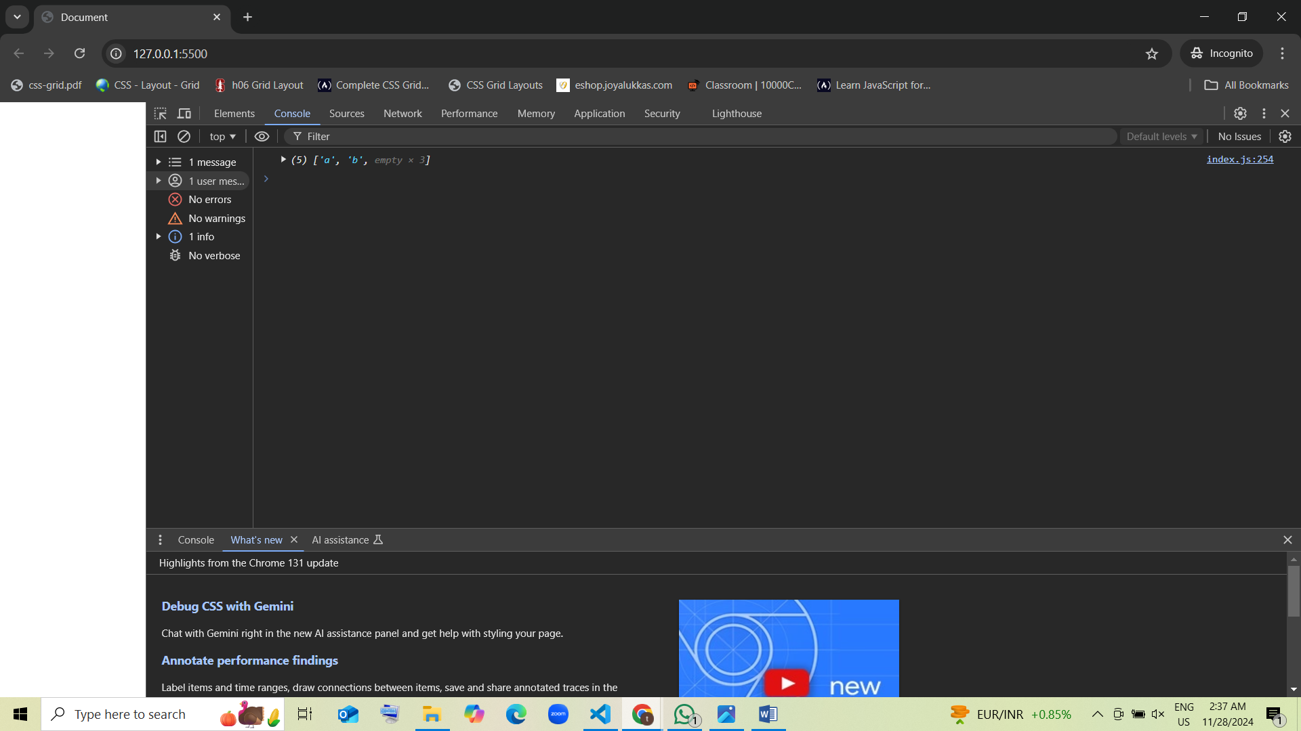

1. Guess the output:

var arr = ["p"];  
arr.push("q");  
arr.unshift("r");  
arr.shift();  
arr.pop();  
console.log(arr);

* 1. ["q"]
  2. ["p"] guess [correct]
  3. []
  4. Error

